

Jobs for Veterans State Grants (JVSG) Primer

|  |
| --- |
| Last Updated: July 2022 |



**WELCOME**

Congratulations on your recent job appointment! To help orient you to your new job, the National Veterans’ Training Institute (NVTI) has designed this primer to assist newly hired Jobs for Veterans State Grants (JVSG) state staff and supervisors in understanding and applying the legal requirements to their jobs. You will gain a basic understanding of the JVSG mission, vision, policies, and your responsibilities as an employee as required by federal law and guidance. It was prepared to make you aware of what you can expect as you serve job-seeking veterans and what the U.S. Department of Labor, Veterans’ Employment and Training Service (DOL VETS) will expect from you.

Table of Contents

What is the Department of Labor, Veterans’ Employment and Training Service? 4

What are jobs for veterans state grants? 7

What is it like to work in an American Job Center? 8

Mission of AJC 8

Vision of AJC 8

[Staff Roles in An American Job Center 10](https://managementconcepts-my.sharepoint.com/personal/msiddiqui_managementconcepts_com/Documents/Documents/NVTI/Primers/JVSG%20Primer/JVSG%20Primer_V3_FInal.docx#_Toc109826983)

Intake Staff Member 11

Staff Conducting Initial Assessment 11

Workforce Innovation and Opportunity Act (WIOA) Staff 11

Business Service Team (BST) Member 11

Disabled Veterans’ Outreach Program (DVOP) Specialist 12

Local Veterans’ Employment Representative (LVER) 13

Consolidated DVOP specialist and LVER position 13

What lEGAL AND rEGULATORY gUIDANCE aFFECTS mY wORK? 14

Legislation and Regulations Relevant to Disabled Veterans’ Outreach Program Specialists 15

Legislation and Regulations Relevant to Local Veterans’ Employment Representatives 17

VETERANS’ PROGRAM LETTERS (VPLS) 18

RELEVANT TRAINING AND EMPLOYMENT NOTICES (TENs) 20

PRIORITY OF SERVICE FOR COVERED PERSONS 22

DVOP Eligible Populations: 23

Veterans with Significant Barriers to Employment (SBE) 23

SERVING VETERANS ENTITLED TO BENEFITS UNDER THE CHAPTER 31 PROGRAM 24

Workforce Innovation and Opportunity Act (WIOA) 24

Purpose of WIOA 24

[The Wagner-Peyser Act 26](https://managementconcepts-my.sharepoint.com/personal/msiddiqui_managementconcepts_com/Documents/Documents/NVTI/Primers/JVSG%20Primer/JVSG%20Primer_V3_FInal.docx#_Toc109827002)

[HIRE Vets Act 26](https://managementconcepts-my.sharepoint.com/personal/msiddiqui_managementconcepts_com/Documents/Documents/NVTI/Primers/JVSG%20Primer/JVSG%20Primer_V3_FInal.docx#_Toc109827003)

What Additional Guidance Exists to Help Get Me Started? 28

What is the National Veterans’ Training Institute? 28

Role-Specific Core Competency Courses 30

Individual Employment Plan (IEP) 31

IEP CONTENTS 31

Comprehensive Assessment 32

Preparing Interview Questions 32

CONSISTENT CONTACT 33

What resources might I find useful to reference? 34

Terms and Definitions 37

Acronyms 41

# What is the Department of Labor, Veterans’ Employment and Training Service?

******The Veterans’ Employment and Training Service (VETS) is an office within the U.S. Department of Labor (DOL). VETS is led by the Assistant Secretary and two Deputy Assistant Secretaries.

**The mission of the U.S. Department of Labor (DOL)** is to “foster, promote, and develop the welfare of the wage earners, job seekers, and retirees of the United States.”

**The mission of the Veterans’ Employment Training Service (VETS)** is to “prepare America’s veterans, service members, and their spouses, for meaningful careers, provide them with employment resources and expertise, protect their employment rights and promote their employment opportunities.”

***Refer to Website:***For more information about VETS, visit:[**https://www.dol.gov/agencies/vets**](https://www.dol.gov/agencies/vets)**.**

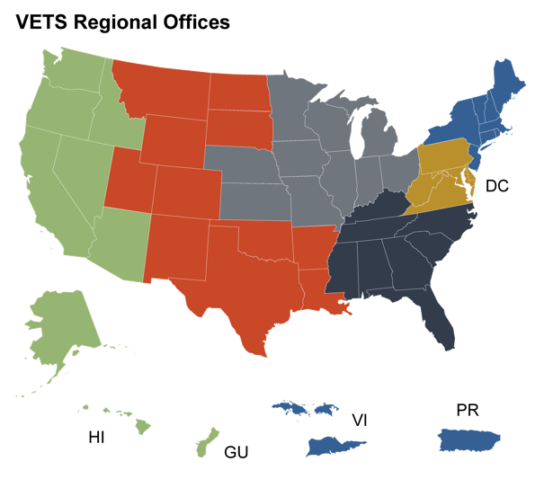The VETS National Office (NO) supports regional offices (RO) and state offices (SO) and includes the Office of Strategic Outreach (OSO) along with six Regional Veterans’ Employment Coordinators (RVECs).

******VETS is administered through six regional offices in Atlanta, Boston, Chicago, Dallas, Philadelphia, and San Francisco.

***Refer to Website:***For more information about regional offices, visit:[**https://www.dol.gov/agencies/vets/about/regionaloffices**](https://www.dol.gov/agencies/vets/about/regionaloffices)

|  |  |
| --- | --- |
| **Each Regional Office**  is led by a Regional Administrator for Veterans’ Employment and Training (RAVET). | **Each State Office**  is led by a Director for Veterans’ Employment and Training (DVET) and, depending on size, may have an Assistant Director(s) for Veterans’ Employment and Training (ADVET), and/or a Veterans Program Assistant (VPA). |

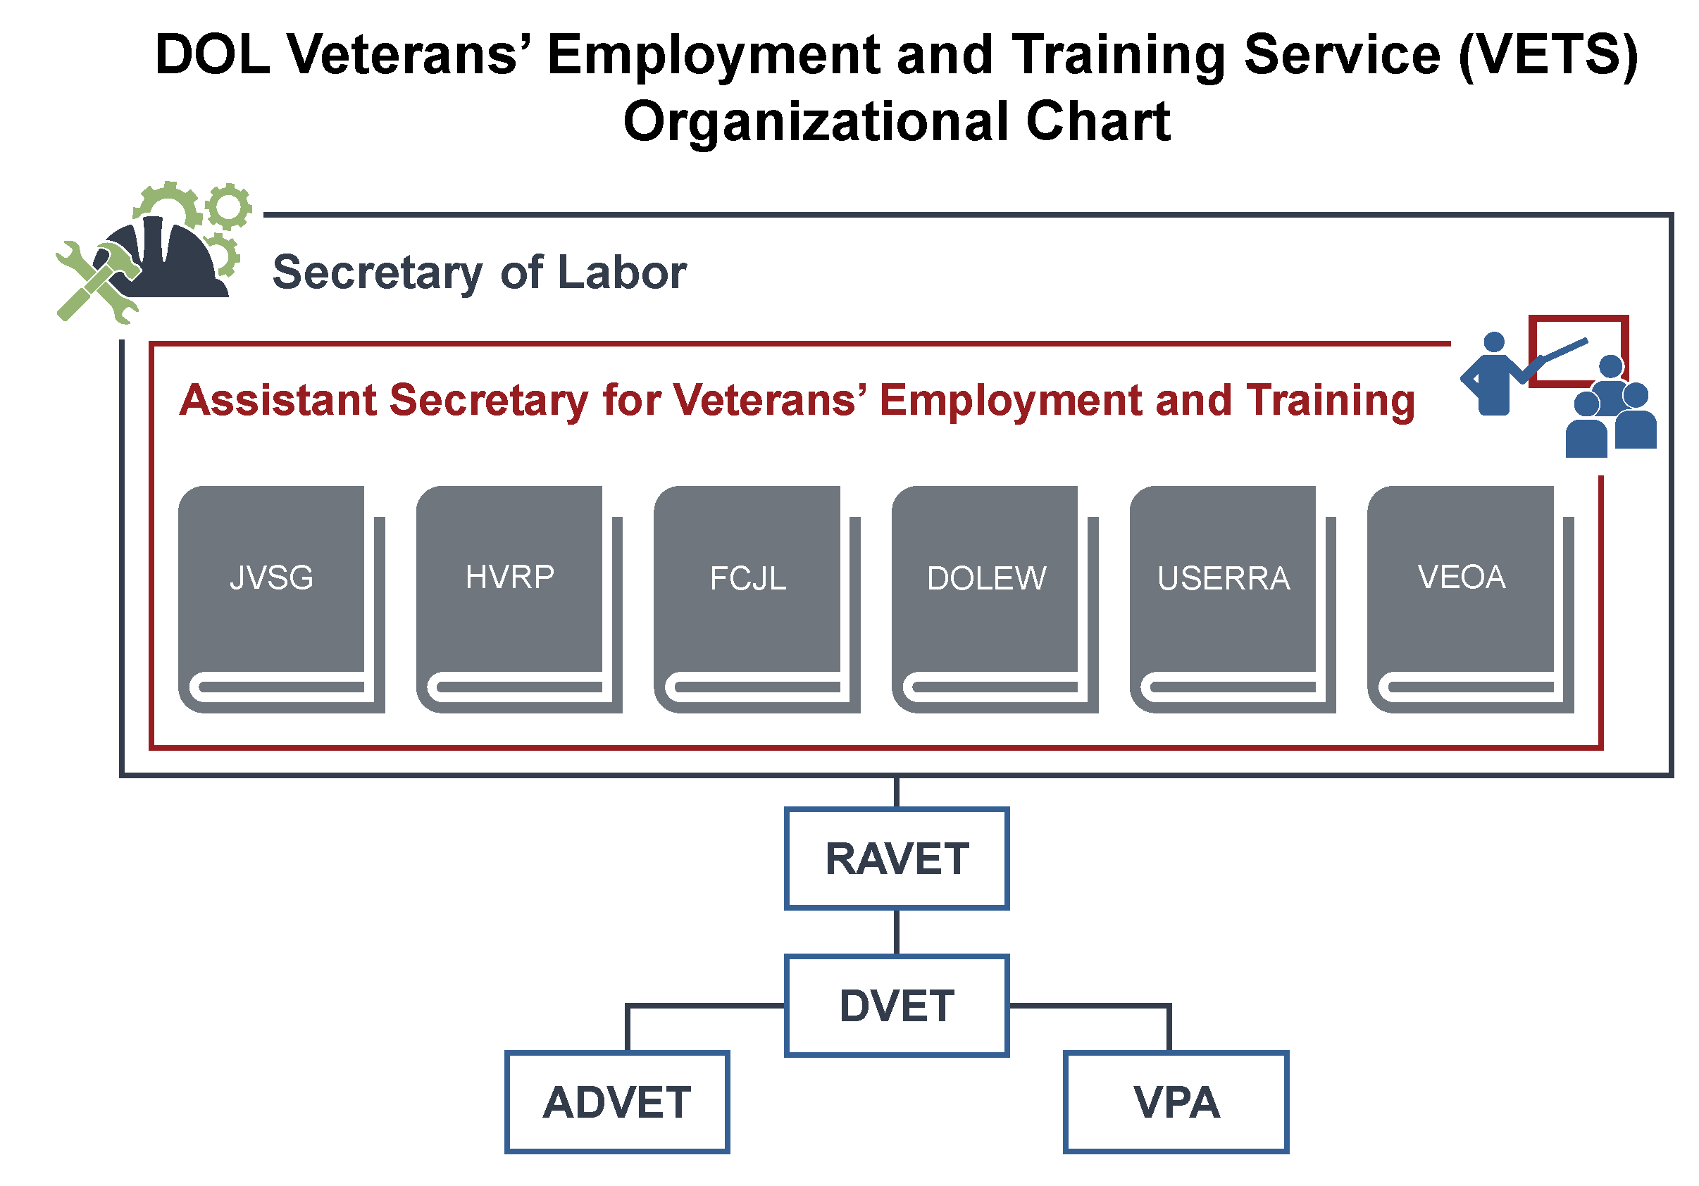

**VETS**

An infographic that is divided into four quadrants: prepare, provide, protect, and promote - depicting the mission of VETS and the programs it supports.
Red quadrant: Prepare America's veterans, service members, and their spouses for meaningful careers; DOL Employment Workshops
Blue quadrant: Provide them with employment resources and expertise; Workforce Development, SWA/JVSG/AJC/HVRP
Green quadrant: Protect their employment rights; USERRA and Veterans' Preference
Orange quadrant: Promote their employment opportunities; SWA, JVSG, AJC, HVRP

# What are jobs for veterans state grants?

The Jobs for Veterans State Grants (JVSG) program provides federal funding, through a formula grant, to 54 State Workforce Agencies (SWAs) to hire dedicated staff to provide individualized career- and training-related services to eligible veterans and eligible persons with significant barriers to employment (SBEs), as well as other authorized populations, and help employers fill their workforce needs with job-seeking veterans.

**The JVSG funding supports the Disabled Veterans’ Outreach Program (DVOP) specialist position, Local Veterans’ Employment Representative (LVER) staff, and Consolidated Position staff.**

**DVOP specialists provide individualized career services to eligible veterans and eligible spouses experiencing significant barriers to employment, as well as other additional populations authorized by the Secretary, with an emphasis on assisting veterans who are economically or educationally disadvantaged. Veterans facing these barriers include veterans experiencing homelessness and vocational rehabilitation clients.**

**LVER staff conducts outreach to employers to determine if their employment needs are being met by American Job Centers (AJCs). They also work with businesses, contractors, and employer organizations to develop career opportunities for veterans.**

**Consolidated Position staff serve in a dual role as a DVOP specialist and an LVER.**

# What is it like to work in an American Job Center?

American Job Centers (AJCs) are sponsored and coordinated through the DOL. Some states have organizations that are a part of AJCs but are called something different. The services at these centers are extended to both job seekers and employers.

|  |  |
| --- | --- |
| Mission of AJC Deliver workforce information and services that assist job seekers, students, workers, workforce intermediaries (organizations that proactively address workforce needs), and employers to develop their capacity and make sound economic decisions.  **The mission aims to:**   * Provide job seekers with the skills and credentials necessary to secure and advance in employment with wages that sustain themselves and their families * Provide access and opportunities to job seekers, including individuals with significant barriers to employment (SBEs), as defined in section 3(24) of the Workforce Innovation and Opportunity Act (WIOA), such individuals with disabilities, individuals who are English language learners, and individuals who have low levels of literacy, to prepare for, obtain, retain, and advance in high-quality jobs and high-demand careers * Enable businesses and employers to easily identify and hire skilled workers and access assistance from human resources, including education and training for their current workforce, which may include assistance with pre-screening applicants, | writing job descriptions, offering rooms for interviewing, and consultation services on topics like succession planning and career ladder development, and other forms of assistance   * Participate in rigorous evaluation that supports continuous improvement of AJCs by identifying which strategies work best for different populations  Vision of AJC To be the nation’s most trustworthy provider of comprehensive, integrated, relevant, and personalized workforce information through the use of an electronic delivery system; to provide tools and resources that serve individuals in enhancing their employment opportunities.  The vision for the AJC network reflects the longstanding and ongoing work of dedicated workforce professionals to align a wide range of publicly or privately funded education, employment, and training programs with one another, while also providing high-quality customer service to all job seekers, workers, and businesses. |

|  |  |
| --- | --- |
| **Job Seekers** | **Employers** |
| Benefits provided to job seekers include:   * Expanded workforce services for individuals at all levels of skill and experience * Access to multiple employment and training resources * Integrated and expert intake process for all customers entering the AJC * Integrated and aligned business services strategy among AJC partners * Expert advice from multiple sources * Relevance to labor market conditions * Expanded community and industry outreach * Strengthened partnerships * Efficient use of accessible information technology | To support area employers, AJC staff must:   * Have a clear understanding of industry skill needs * Identify appropriate strategies for assisting employers, and coordinate business services activities across AJC programs, as appropriate * Incorporate an integrated and aligned business strategy among AJC partners to present a unified voice for the AJC in its communications with employers   There are also some customized business services that may include:   * Customized screening and referral of qualified participants in career and training services to employers * Writing/reviewing job descriptions and employee handbooks |

AJCs provide many tools and resources to job seekers and employers, including but not limited to:

  

Career management

Assistance acquiring a desired career

Employment information and inspiration for potential careers

Employers also receive help in finding skilled employees that fit their needs.



## Staff Roles in An American Job Center

The staff found in AJCs may include the following:

* Intake staff member (typically an Employment Services Interviewer)
* Staff member who conducts the initial assessment (funded under the Wagner-Peyser Act)
* Workforce Innovation and Opportunity Act (WIOA) staff
* Business Service Team (BST) member
* JVSG-funded staff members:
  + Disabled Veterans’ Outreach Program (DVOP) specialist
  + Local Veterans’ Employment Representative (LVER)
  + Consolidated DVOP specialist and LVER position

**The exact job title of these staff members may vary depending on the state they work in.**

| **Non-JVSG Funded Staff Role** | **Responsibilities** |
| --- | --- |
| intake staff memberIntake Staff Member | The intake staff member, serving as a “greeter,” is usually the first person that a veteran at an AJC would interact with. Their primary role is to determine the reason for an individual’s visit to the AJC. They may also provide the initial determination of whether an individual meets the definition of an eligible veteran or other authorized population as prescribed by law. They also sometimes share the role of a staff member conducting the initial assessment. This role may not exist in some states if the intake process is an automated electronic process completed in the AJC’s resource room area. Once the intake staff member has determined the appropriate staff person to assist the job seeker, they make a referral. |
| employment services interviewerStaff Conducting Initial Assessment | The staff member who conducts the initial assessment is a non-JVSG role that is designated specifically for job seekers and is sometimes combined with the intake process. They conduct an assessment to determine priority of service and whether a participant is eligible. Eligible populations are referred to a DVOP specialist. If the individual does not meet eligibility criteria, an employment specialist (non-JVSG staff) can assist them with receiving appropriate services that are available at the AJC such as resume writing, computer skills, and interviewing techniques. If they need more specialized training, they will work with another service provider within an AJC. The staff also have a broad knowledge of other services available to clients from other governmental agencies and community-based organizations. |
| WIOA staff memberWorkforce Innovation and Opportunity Act (WIOA) Staff | As described under Title I of the Workforce Innovation and Opportunity Act (WIOA), the WIOA staff focuses on serving individuals identified as facing adversity with obtaining employment. Should a veteran need their services, they would assist individuals with services that prepare them with the skills needed on the job, such as providing skills-gap training for individuals needing certification or licensure. The type of training that WIOA staff assists veterans with varies depending on the state in which they work. Local colleges or businesses may reach out with potential training ideas and if they are approved, WIOA staff will match veterans to any approved training that best fits their needs/wants. |
| business service team memberBusiness Service Team (BST) Member | The Business Service Team (BST) member is a part of the AJC staff and is essentially responsible for coordinating with the community and employers to promote and secure employment and training opportunities for all job seekers. |

| **JVSG-Funded Staff Role** | **Responsibilities** |
| --- | --- |
| DVOP specialistDisabled Veterans’ Outreach Program (DVOP) Specialist | The DVOP specialist works directly with eligible veterans and eligible persons who have significant barriers to employment, and other authorized populations, as identified in VETS policies; their duties are outlined in 38 U.S.C. 4103A. The services provided by a DVOP specialist are referred to as individualized career services but were once called intensive services. These services include, but are not limited to:   * Comprehensive assessment interviews * Career guidance services * Individual Employment Plans (IEPs) * Staff-assisted job search activities * Staff-assisted career follow-up services   A full list of services can be found in 20 CFR § 678.430.  DVOP specialists focus on providing individualized career services through the case management approach, as taught by the National Veterans’ Training Institute (NVTI). This approach includes three elements: Comprehensive Assessment, Employment Plan, and Consistent Contact. Additionally, DVOP specialists also conduct relationship building as well as outreach and recruitment activities with other service providers in the local area, to enroll eligible and priority category veterans in an AJC.  It is important for a DVOP specialist to establish a strong rapport and relationship with the veterans they serve, in order to provide them with the best services possible to help them reach their employment goals. |
| LVER  Local Veterans’ Employment Representative (LVER) | The LVER staff members perform a wide range of duties on behalf of our veterans specifically related to outreach to the employer community and facilitation within the state’s employment service delivery system. These duties are outlined in 38 U.S.C. 4104(b). LVERs must be assigned duties that promote the advantages of hiring veterans to employers, employer associations, and business groups. LVERs advocate for all veterans served by the AJCs with business, industry, and other community-based organizations by participating in appropriate activities such as:   * Planning and participating in job and career fairs * Conducting employer outreach * In conjunction with employers, conducting job searches and workshops, and establishing job search groups * Coordinating with unions, apprenticeship programs, and businesses or business organizations to promote and secure employment and training programs for veterans * Informing federal contractors of the process to recruit qualified veterans * Coordinating and participating with other business outreach efforts   LVERs are members of the business service team.  LVERs are also responsible for “facilitating employment, training, and placement services furnished to veterans in a State under the applicable State employment service delivery systems” (38 U.S.C. 4104(b)(2)).  It is important to note that some of these functions may be performed by other AJC staff. |
| consolidated position staff memberConsolidated DVOP specialist and LVER position | Consolidated Staff positions perform both the duties of a DVOP specialist and an LVER staff person. |





***Refer to Website:***

For more information about Title 38 Chapters 41 and 42, visit:

[**https://nvti.org/Resources/NVTI-Resources**](https://nvti.org/Resources/NVTI-Resources)

# What lEGAL AND rEGULATORY gUIDANCE aFFECTS mY wORK?

The United States Code (U.S.C.) that is relevant to DOL VETS’ authority under the JVSG program is Title 38, Chapters 41 and 42.

* **Chapter 41, Section 4102A** discusses allowance for a JVSG staff person to perform duties of a DVOP specialist and a LVER staff person as a Consolidated Position
* **Chapter 41, Section 4103A**   
  discusses the Disabled Veterans’ Outreach Program
* **Chapter 41, Section 4104** discusses Local Veterans’ Employment Representatives
* **Chapter 42, Sections 4211—4215**   
  provide detailed descriptions for many of the terms relevant to DOL VETS under the JVSG program

## Legislation and Regulations Relevant to Disabled Veterans’ Outreach Program Specialists

The legislation, regulations, and policy specific to Disabled Veterans’ Outreach Program specialists include:

| Legislation and/or Regulations | Description |
| --- | --- |
| U.S.C. Title 38, Chapter 41, Section 4103A | U.S.C. Title 38, Chapter 41, Section 4103A requires that Disabled Veterans’ Outreach Program specialists provide individualized career services (intensive services) and facilitate job placement to eligible veterans. |
| Public Law 113-128, the Workforce Innovation and Opportunity Act, Section 134(c)(2) | Public Law 113-128, the Workforce Innovation and Opportunity Act (WIOA), Section 134(c)(2) outlines the individualized career services (also previously known as intensive services) that are to be provided by the Disabled Veterans’ Outreach Program specialist to eligible participants. |
| Consolidated Appropriations Act | The Consolidated Appropriations Act includes language authorizing DVOP specialists to serve eligible transitioning service members and members of the armed forces who are wounded, ill, or injured receiving treatment at a warrior transition unit or military treatment facility, as well as the spouses or caregivers of such wounded, ill, or injured members. |
| VPL 03-14 | VPL 03-14 defines the roles and responsibilities of the JVSG staff. Change 1 clarified and expanded the definition of significant barriers to employment. Change 2 clarified and expanded the definition of homelessness as a significant barrier to employment. |
| VPL 03-19 | VPL 03-19 defines additional populations who may receive services from Disabled Veterans’ Outreach Program specialists. VPL 03-19 added the population of Vietnam-era veterans to the list of already identified eligible populations. |
| VPL 01-16, Change 1  Technical Assistance Guide (TAG) | VPL 01-16, Change 1 provides information on serving veterans found entitled to benefits under the Chapter 31 program by the Department of Veterans Affairs (VA) Veteran Readiness and Employment (VR&E) service. Because veterans entitled to this program are service-connected disabled, they are automatically classified as having a significant barrier to employment. This VPL contains a Technical Assistance Guide that describes this joint partnership between DOL VETS, VA/VR&E, and the SWAs, what services are to be provided, and the roles and responsibilities of each partner. |

**

***Refer to Website:***For more information about legislation and regulations specific to Disabled Veteran’s Outreach Program specialists and to access online training for Serving Veterans Enrolled in the Chapter 31 program visit: [**https://www.nvti.org/Resources**](https://www.nvti.org/Resources)**.**

## Legislation and Regulations Relevant to Local Veterans’ Employment Representatives

The legislation, regulations, and policy specific to Local Veterans’ Employment Representatives includes:

* U.S.C. Title 38, Chapter 41, Section 4104
* VPL 03-14

|  |  |
| --- | --- |
| **Legislation and/or Regulations** | **Description** |
| **U.S.C. Title 38, Chapter 41, Section 4104** | U.S.C. Title 38, Chapter 41, Section 4104 lists the principal duties of Local Veterans’ Employment Representatives. |
| **VPL 03-14** | VPL 03-14 states that Local Veterans’ Employment Representatives are to serve as advocates for all veterans served by the AJC with business, industry, and other community-based organizations. |

**

***Refer to Website:***For more information about legislation and regulations specific to Local Veterans’ Employment Representatives visit:

[**https://www.nvti.org/Resources**](https://www.nvti.org/Resources)**.**

## VETERANS’ PROGRAM LETTERS (VPLS)

VPLs are the vehicle by which VETS provides additional guidance to the states to clarify veterans’ program requirements. These VPLs are covered in greater detail in future training, however, you are encouraged to review these now. To receive alerts of new or updated VPLs, make sure to subscribe to the VPL Directory.

The Veterans’ Program Letters (VPL) with companion Training and Employment Guidance Letters (TEGL) are listed on the pages that follow.

| **VPL and TEGL** | | **Description** |
| --- | --- | --- |
| **VPL 07-09 & TEGL 10-09** | VPL 07-09 and its companion TEGL 10-09 explain that covered persons, which includes veterans as defined at 38 U.S.C. 101(2) and eligible spouses as defined at section 2(a) of the Jobs for Veterans Act (38 U.S.C. 4215(a)), are eligible for priority of service.  This VPL and TEGL are relevant because the guidance requires recipients, (including sub-recipients), of DOL funds for qualified job training programs to provide priority of service to covered persons. Qualified job training programs means any program or service for workforce preparation, development, or delivery that is directly funded, in whole or in part, by the U.S. Department of Labor (20 CFR 1010.110). Examples of these programs include, all WIOA and Wagner-Peyser funded activities, including technology-assisted activities, Senior Community Service Employment Programs (SCSEPs), Indian and Native American Programs (INAPs), National Farmworker Jobs Programs (NFJPs), Trade Adjustment Assistance (TAA) programs, programs funded through the Women’s Bureau, and any other current or future qualified job training programs. |
| **VPL 03-14 with Changes 1 & 2, and its companion TEGL 19-13** | VPL 03-14, including Changes 1 and 2, and the companion TEGL 19-13 define the criteria for having significant barriers to employment (SBEs) and provide expansion and clarification of SBEs.  These policy guidance documents are relevant because they identify and clarify populations who are eligible to receive services from DVOP specialists. |
| **VPL 03-19 & TEGL 20-13, Change 2** | VPL 03-19 and TEGL 20-13, Change 2, define additional populations who may receive services from DVOP specialists.  These policy guidance documents are relevant because it added the population of Vietnam-era veterans to the list of already identified eligible populations. |
| **VPL 03-16 & TEGL 04-16** | VPL 03-16 and its companion TEGL 04-16 provide guidance and information on the requirement to have participants of the DOL VETS’s Homeless Veterans’ Reintegration Program (HVRP) enroll in WIOA Title I workforce programs available through AJCs.  It is especially relevant to DVOP specialists because they provide individualized career services to veterans experiencing homelessness, and HVRP grantees who must enroll their participants into appropriate AJC programs. |

***Refer to Website:***For more information about VPLs and TEGLs visit: [**https://www.dol.gov/agencies/vets/resources/VPLS/VPLDirectory**](https://www.dol.gov/agencies/vets/resources/VPLS/VPLDirectory) where you can also subscribe to receive updates about these resources. You may also access these resources by visiting: [**https://www.nvti.org/Resources**](https://www.nvti.org/Resources).

## RELEVANT TRAINING AND EMPLOYMENT NOTICES (TENs)

While there are not any Training and Employment Notices (TENs) that correspond to any specific VPLs, there are a few TENs that are relevant to the JVSG program requirements and DVOP specialist and LVER staff roles and responsibilities. These TENs are listed on the pages that follow.

***Refer to Website:***   
For more information about TENs visit: [**https://www.dol.gov/agencies/vets/resources/VPLS/VPLDirectory**](https://www.dol.gov/agencies/vets/resources/VPLS/VPLDirectory)where you can also subscribe to receive updates about these resources. You may also access these resources by visiting: [**https://www.nvti.org/Resources**](https://www.nvti.org/Resources)

| **Training and Employment Notice** | **Description** |
| --- | --- |
| **TEN 08-16** | TEN 08-16 announced the implementation schedule for an integrated performance reporting system for the Employment and Training Administration (ETA) and VETS workforce programs. States are required to collect and report in accordance with the relevant indicators of performance identified in section 116(b) starting July 1, 2016. As of July 1, 2016, all workforce programs, including JVSG, began utilizing the new performance reporting system. |
| **TEN 02-16** | TEN 02-16 announced the availability of the report, *Veterans’ Licensing and Certification Demonstration - A Summary of State Experiences, Preliminary Findings, and Cost Estimates: Final Report; September 2015.* This report provides information on barriers faced by veterans when seeking licensure for civilian jobs. The report also provides strategies for accelerating licensure of veterans, as well as cost savings as a result of accelerating veteran licensure. |
| **TEN 06-15** | TEN 06-15 announced the release and availability of the interim report, *Veterans’ Licensing and Certification Demonstration*. This TEN also provides an overview of a framework to help states accelerate licensing and certification into civilian occupations for veterans and transitioning service members. |
| **TEN 15-10** | TEN 15-10 provides information, suggestions, and examples about how to effectively implement priority of service to meet the requirements of DOL regulations. |

## PRIORITY OF SERVICE FOR COVERED PERSONS

****VPL 07-09 and its corresponding TEGL 10-09 discuss *Implementing Priority of Service for Veterans and Eligible Spouses in all Qualified Job Training Programs funded in whole or in part by the U.S. Department of Labor*. The VPL and TEGL explain that veterans and eligible spouses are eligible for priority of service.

VPL 07-09, TEGL 10-09, and Title 20 of the CFR, Section 1010 define veterans and eligible spouses and explain the provision of priority of service for covered persons (i.e., veterans and eligible spouses) over non-covered persons for the receipt of employment, training, and placement services under a qualified job training program, funded in whole or in part by the Department of Labor.

**TEGL 10-09 states:**

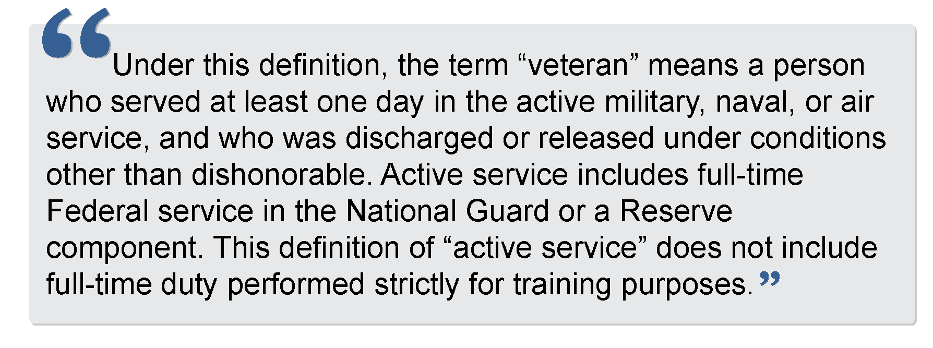

U.S.C. Title 38, Chapter 42, Section 4215(a) states an eligible spouse means one of the following:

* Any veteran who died of a service-connected disability
* Any member of the Armed Forces serving on active duty who, at the time of application for priority of service, is listed in one or more of the following categories and has been so listed for a total of more than 90 days:
  1. Missing in action,
  2. Captured in line of duty by a hostile force, or
  3. Forcibly detained or interned in the line of duty by a foreign government or power.
* Any veteran who has a total disability resulting from a service-connected disability, as evaluated by the Department of Veterans Affairs
* Any veteran who died while a disability, so evaluated, was in existence

## DVOP Eligible Populations:

### Veterans with Significant Barriers to Employment (SBE)

For veterans to be eligible to work with a DVOP specialist, they must meet the definition as an eligible veteran (as defined in 38 U.S.C. § 4211) or eligible spouse (as defined 38 U.S.C. § 4101) attesting one or more significant barriers to employment or be designated as a special population as defined in VPL 03-19.

VPL 03-14, Changes 1 and 2 defines the criteria for SBEs and provide expansion and clarification of SBEs. States may use an Eligibility Triage Form to determine eligibility for DVOP specialist services.

***Refer to Website:***You may learn more about the *Eligibility Triage Form* by watching NVTI’s microlearning on this topic at: [**https://nvti.org/Resources/NVTI-Microlearning**](https://nvti.org/Resources/NVTI-Microlearning) under the topic heading *Serving Veterans*.

**Significant barriers to employment (SBEs)** include:

* A special disabled or disabled veteran
* Homelessness
* A recently separated service member who’s been unemployed any time within the previous 12 months for 27 or more weeks
* An offender who is currently justice-involved or has been released from incarceration
* Lacking a high school diploma or equivalent certificate
* Low-income individual

**Special Populations** include:

1. Eligible veterans aged 18 to 24
2. A transitioning service member in need of intensive services
3. A wounded, ill, or injured service member receiving treatment at Military Treatment Facilities or Warrior Transition Units as well as the spouses and family caregivers of such wounded, ill, or injured service members
4. Eligible Vietnam-era veterans

## **SERVING VETERANS ENTITLED TO BENEFITS UNDER THE CHAPTER 31 PROGRAM**

VPL 01-16, Change 1 provides a Technical Assistance Guide (TAG) that provides guidance on serving veterans found entitled to Chapter 31 program benefits by the Department of Veterans Affairs (VA) Veteran Readiness and Employment (VR&E) Service. These individuals are service-connected disabled veterans and, as such, are eligible to work with a DVOP specialist.

The TAG describes standard operating procedures for all partners, including the VA/VR&E, DOL/VETS, and the State Workforce Agency staff to work with Chapter 31 veterans. It outlines the roles and responsibilities of each organization and the processes to be followed to ensure Chapter 31 veterans achieve successful employment outcomes.



Within the framework identified in the TAG, DVOP specialists are tasked with providing labor market information for the VA/VR&E service to use in developing the veteran’s Individualized Written Rehabilitation Plan (IWRP) and Employment Services during the employment phase of the veteran’s rehabilitation.

## Workforce Innovation and Opportunity Act (WIOA)

The Workforce Innovation and Opportunity Act (WIOA) was signed into law in July 2014 and supersedes the Workforce Investment Act of 1998.

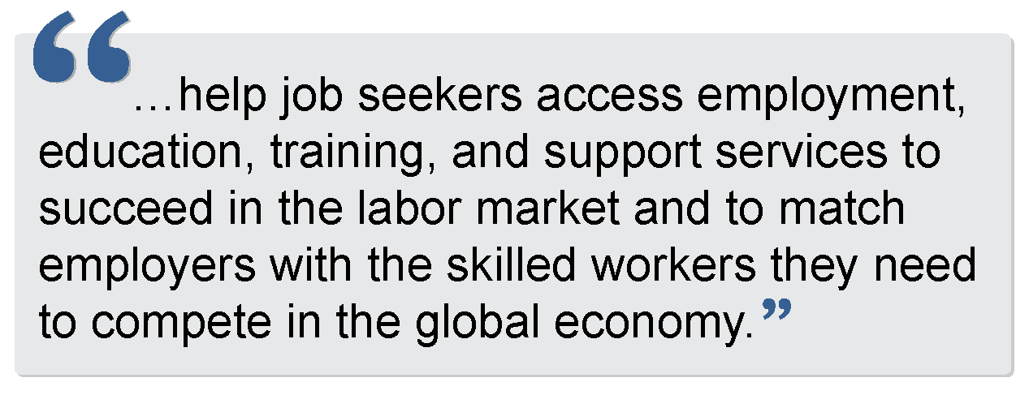Purpose of WIOA**:**

WIOA focuses on serving populations with SBEs. These priority populations include:

* Recipients of public assistance
* Other low-income individuals
* Individuals who are basic skills deficient in the provision of individualized career services. Basic skills deficient is defined as someone:
  1. Who is a youth, with English reading, writing, or computing skills at or below the 8th grade level on a generally accepted standardized test.
  2. Who is a youth or adult, that is unable to compute or solve problems, or read, write, or speak English, at a level necessary to function on the job, in the individual’s family, or in society.

Priority of service in relation to WIOA is provided using the following order:

to non-covered persons (that is, individuals who are not veterans or eligible spouses) who are included in the groups given priority for WIOA adult formula funds.

to veterans and eligible spouses who are also included in the groups given statutory priority for WIOA adult formula funds. This means that veterans and eligible spouses who are also recipients of public assistance, other low-income individuals, or individuals who are basic skills deficient would receive first priority for services provided with WIOA adult formula funds.

.

*******Refer to Website:***For more information about WIOA visit: [**https://www.dol.gov/agencies/eta/wioa**](https://www.dol.gov/agencies/eta/wioa) or

to priority populations established by the governor and/or local WBD and then non-covered persons outside the groups given priority under WIOA.

to veterans and eligible spouses who are not included in WIOA’s priority groups.

[**https://www.nvti.org/Resources**](https://www.nvti.org/Resources)

***Refer to Website:***

For more information about the HIRE Vets Act visit: [**https://www.hirevets.gov/about**](https://www.hirevets.gov/about)

***Refer to Website:***

For more information about the Wagner-Peyser Act visit: [**https://www.dol.gov/agencies/eta/performance/results/wagner-peyser**](https://www.dol.gov/agencies/eta/performance/results/wagner-peyser)

## The Wagner-Peyser Act

In 1933, the Wagner-Peyser Act was established, creating the Employment Service which brings together job seekers and employers seeking workers.

In 1998, the act was amended to make the Employment Service part of the One-Stop delivery system under the Workforce Investment Act.

In 2014, the act was amended again under WIOA. Under WIOA, the act builds upon the previous workforce reforms, requires the placement of Employment Service offices into the AJCs nationwide, and aligns performance accountability indicators with other federal workforce programs.

Job seekers who are veterans or other eligible persons are to receive priority for job referrals, training programs, and other services.

## HIRE Vets Act

The Honoring Investments in Recruiting and Employing American Military Veterans Act of 2017, or the HIRE Vets Act, encourages effective, voluntary investments to recruit, employ, and retain men and women who have served in the United States military with annual federal awards to employers. Created under the HIRE Vets Act, the HIRE Vets Medallion Program recognizes companies and organizations for their efforts to recruit and retain America’s military service veterans.

The program launched as a demonstration in 2018 and was fully implemented in 2019. The HIRE Vets Medallion Program provides a way to recognize companies and organizations that make a strong commitment to hiring veterans. The Department’s Veterans’ Employment and Training Service details the criteria, process, timelines, and procedures for employers to follow to qualify and apply for the award in TEGL 09-18 and VPL 02-19.

**There are different awards for large employers (500 or more employees), medium employers (51-499 employees), and small employers (50 or less employees). There are two award tiers: Gold and Platinum.**

****The criteria for the awards are as follows:

1. Percentage of new hires who are veterans in the prior year.
2. Percentage of veteran employees retained for a period of at least 12 months.
3. Percentage of employees who are veterans.
4. Providing an employee veteran organization or resource group to help new veteran employees with integration, including coaching and mentoring.
5. Providing programs to enhance leadership skills of veteran employees.
6. Having a dedicated human resource professional or initiatives to support hiring, training, and retention of veteran employees.
7. Providing compensation to employees serving on active duty in the U.S. National Guard or Reserve that is sufficient, in combination with the employee’s active duty pay, to achieve a combined level of income commensurate with the employee’s salary prior to undertaking active duty.
8. Providing a tuition assistance program to support veteran employees’ attendance in postsecondary education during their employment.
9. No employer with an adverse labor law decision, stipulated agreement, contract debarment, or contract termination will be eligible to receive an award.

To be eligible for the award, not all the above-mentioned criteria must be satisfied, with the exception of Criteria No. 9.

# What Additional Guidance Exists to Help Get Me Started?

## What is the National Veterans’ Training Institute?

The National Veterans’ Training Institute (NVTI), established in 1986, seeks to improve the development and enhancement of the professional skills of JVSG-funded staff and VETS staff. NVTI is funded by DOL VETS.

NVTI does not directly work with or train veterans. NVTI is a contract program from DOL VETS. NVTI is mandated by law (U.S.C. Title 38, Section 4109) to provide specific training to certain groups, namely veterans’ employment and training professionals including employment service personnel, VETS and state staff, Department of Defense personnel, and others.

**NVTI required courses infographic 

First box, shows screenshot of the First Prerequisite: 9635, A day in the life of JVSG staff in an American Job Center. Self-paced e-learning 1-3.5 hours. This course presents a broad overview of how an AJC operates and the roles and responsibilities of each staff member.

Second box, shows a screenshot of the modules for the second prerequisite: 9636, legal guidance affecting veterans' employment services. Online with instructor support. 3-4 hours per week for 4 weeks. This course presents important provisions of veteran-related legislation and regulations and the legal relationship between AJC staff and presents the VETS and JVSG programs.

Third box, shows a screenshot of the modules for the third prerequisite: 9637, removing the employability gap for veterans with significant barriers to employment (SBE). Online with instructor support, 3-4 hours a week for 2 weeks. This course presents strategies for effectively developing working relationships with veterans and techniques to interact with veterans and employers and explores the contents of an IEP.
**

#### **Role-Specific Core Competency Courses**:

**DVOP Only:** 9608: Disabled Veterans’ Outreach Program (DVOP) Specialist Core Competency Development (Virtual or NVTI Training Center, Dallas, TX)

This course provides DVOP specialists with the training, skills, and tools needed to assist veterans with finding and keeping meaningful employment. From building relationships with veterans to developing concrete plans that will enable veterans to transition from unemployment to following a promising career path, participants will engage in exercises, discussions, and activities that will prepare them to tackle the unique obstacles they face on the job. This course is classroom-based and is delivered over three and a half days at the NVTI Training Center in Dallas, TX. Because of the prerequisite courses, participants are expected to attend ready to engage in discussions and activities. The course ends with a graded cumulative assessment, which is required by the authorizing legislation.

**LVER Only:** 9609: Local Veterans’ Employment Representative (LVER) Core Competency Development (Virtual or NVTI Training Center, Dallas, TX)

Local Veterans’ Employment Representatives (LVERs) advocate for job-seeking veterans by serving as liaisons with employers and training providers. This course empowers LVERs to conduct a variety of outreach activities, thus facilitating employment opportunities for job-seeking veterans through their AJCs (AJCs). Participants are provided with the strategies and tools they need to help veterans gain and maintain meaningful employment. This course is classroom-based and is delivered over three and a half days at the NVTI Training Center in Dallas, TX. Because of the prerequisite courses, participants are expected to attend ready to engage in discussions and activities. The course ends with a graded cumulative assessment, which is required by the authorizing legislation.

Please note: VPL 01-20 provides for Consolidated DVOP Specialist and LVER staff positions. All required training for both DVOP and LVER positions must be successfully completed within 18 months of appointment.

Please speak with your supervisor, who will then work with the State Veterans Coordinator (SVC) to arrange the training with NVTI.

***Refer to Website:***For additional information and training opportunities, visit: [**https://www.nvti.org/Training/Class-Descriptions**](https://www.nvti.org/Training/Class-Descriptions)**.**

## Individual Employment Plan (IEP)

An IEP is a written plan that identifies employment/career goals, barriers to employment identified during the comprehensive assessment, and steps to overcome the barriers and achieve the goals. The plan should be fluid and updated as appropriate. These may have different titles in your state.

There are many reasons as to why the development of an IEP is critical. It’s important for both you, and the participant you are working with, to know these reasons. It adds purpose to a process.

Individual Employment Plans:

* **Provide a plan for the participant that will also help guide the DVOP specialist.** A plan provides steppingstones to goal achievement and provides accountability for those involved.
* **Help set expectations.** Both the DVOP specialist and participant will be on the same page.
* **Build self-esteem.** An IEP helps participants see that their goals are attainable.
* **Provide a guide for effectively assisting the participant.** Align your goals and plans with those of the veteran with whom you are working.
* **Increase the number of placements and success stories.** When goals are written down, multiple people can have access to them, allowing for the increase of assistance provided for a participant. Also, it’s been noted that goals that are written down are likelier to be met.
* **Help facilitate meaningful follow up.** This provides the DVOP specialist with a reason to follow up with participants to monitor their progress toward goal achievement.

### IEP CONTENTS

IEPs vary by state, but the basic contents include:

* Employment goals
* Barriers to employment
* Plan to overcome barriers to find employment
* Referrals to other agencies



***Refer to Website:***For more information about IEPs watcht NVTI’s microlearning by visiting: [**https://www.nvti.org/Resources/NVTI-Microlearning**](https://www.nvti.org/Resources/NVTI-Microlearning%20) .

## Comprehensive Assessment

A comprehensive assessment is used to identify significant barriers to employment by obtaining as much information as possible related to attaining and maintaining employment. A common method for administering and conducting these assessments is to use informal assessments such as a structured interview. There is no one instrument or technique that can provide all the answers, which is why attempts to get as many pieces of the puzzle as possible is important.

Conducting a comprehensive assessment requires a lot of active listening and focus. This comprehensive evaluation serves to understand the participant holistically by finding out where the participant is, what they have done, what they want to do, and what barriers they need to overcome. It is only through accurate and ongoing assessment that an IEP can be created, implemented, monitored, modified, and completed.

Preparing Interview Questions**:**

* **Start easy.** Initially keep the questions less personal; save the more controversial or personal questions for later.
* **Keep it simple and specific.** Ask one question at a time and keep the wording simple and specific. Define anything that may be unfamiliar.
* **Remain neutral.** Keep the wording of questions neutral and non-judgmental. Avoid leading questions. You do not want to project your values and judgements onto others. Be aware of asking *why* questions—they tend to put people on the defensive and may affect your rapport with an individual.
* **Focus on the objective.** Remember what the objective of the interview is; it could be different for each individual. When working with someone who is experiencing homelessness, you want to determine how the current situation occurred and how motivated they are to change their lifestyle. If someone is missing a limb, the more prominent issue is where they are mentally in accepting the situation as well as how the injury will affect work in occupations of interest.
* **Embrace silence.** Try to avoid speaking in moments of silence; at times this can be an effective communication tool and encourages an individual to talk more and reveal more information.
* **Be open to questions.** Give an individual opportunities to ask questions. Ask them if they have any questions periodically or if something appears to be unclear.
* **Summarize.** Wrap up the interview by summarizing what has been discussed and the next steps. This information should be in the plan, and the participant should always leave with a copy of the plan for follow up. It provides the participant with a step-by-step guide for their goals that they can cross off and monitor.

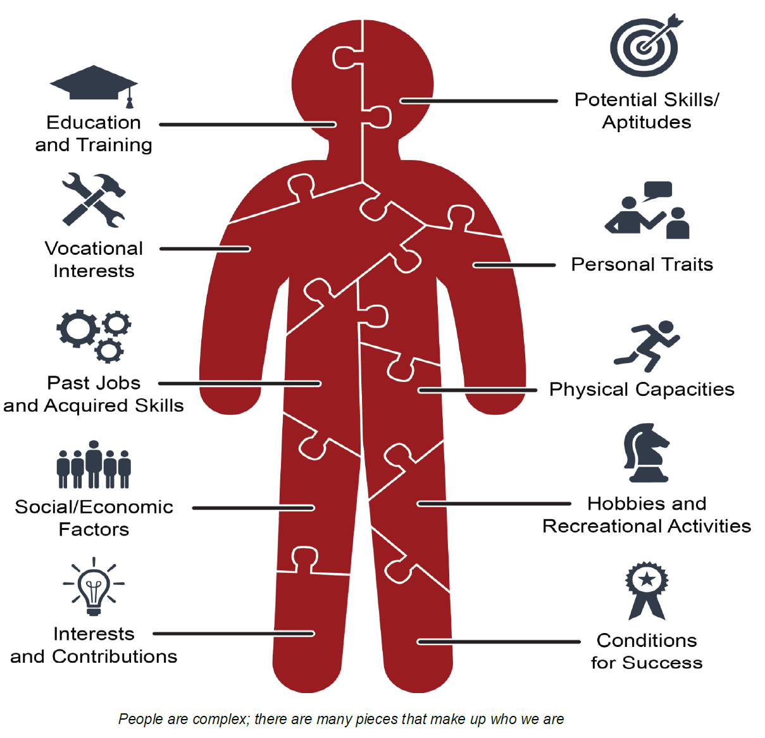

## CONSISTENT CONTACT

******Regular, consistent contact between the DVOP specialist and the eligible participant is critical. Meetings and updates, both pre- and post-employment are important and helps the DVOP specialist determine the level of assistance the participant needs. Consistent contact is based on the participant’s individual needs and situation, as per the written plan and case notes. This also includes any documented attempts at contact.

***Refer to Website:***To learn more about Case Management, check out NVTI courses:  
[**https://www.nvti.org/Training/Class-Descriptions**](https://www.nvti.org/Training/Class-Descriptions)

# What resources might I find useful to reference?

| **Website** | **Description** |
| --- | --- |
| **DOL VETS** | United States Department of Labor – Veterans’ Employment and Training Services (DOL VETS). Resources for all veterans, including information on finding a job, starting a business, hiring veterans, VA benefits and information, and military spouses. |
| **O*Net Online** | A tool for career exploration and job analysis. |
| **Career One Stop** | The source for career exploration, training, & jobs sponsored by the U.S. DOL. |
| **Hire Vets Medallion Program** | Honors the employers who hire our Nation’s veterans. |
| **National Association of State Workforce Agencies (NASWA)** | These agencies deliver training, employment, career, and business services, in addition to administering the unemployment insurance, veteran re-employment, and labor market information programs. |
| **Veterans Career Fairs—American Legion** | The American Legion’s Career Fairs site. |
| **Veterans Career Fairs—DAV** | DAV is a nonprofit charity that focuses on connecting veterans with meaningful employment and resources. |
| **Employer Support of the Guard and Reserve (ESGR)** | ESGR, a Department of Defense program, was established in 1972 to promote cooperation and understanding between Reserve component service members and their civilian employers and to assist in the resolution of conflicts arising from an employee's military commitment. |
| **Marine for Life Network (M4L)** | Connects transitioning Marines and their family members to education resources, employment opportunities, and other veterans’ services that aid in their career and life goals outside of military service. |
| **Military Officers Association of America (MOAA).** | The nation's largest and most influential association of military officers. They represent the interests of military officers and their families at every stage of their careers |
| **United States Army Soldier for Life (SFL)** | The Soldier for Life (SFL) program improves soldier, family, and Army readiness by developing a broad network of resources to support every soldier, veteran, and family member through all phases of their service. |
| **Student Veterans of America** | Student Veterans of America’s mission is to provide military veterans with the resources, support, and advocacy needed to succeed in higher education and following graduation. |
| **United States Chamber of Commerce Foundation – Hiring Our Heroes** | Nationwide initiative to help veterans, transitioning service members, and military spouses find meaningful employment opportunities. |
| **National Veterans’ Training Institute (NVTI)** | NVTI was established to develop and enhance the professional skills of veterans' employment and training service providers throughout the United States. NVTI provides classes and resources such as webinars, microlearnings, podcasts, and a Community of Practice to support VETS service providers. |

***Refer to Website:***

To find links to these resources, visit:

[**https://nvti.org**](https://nvti.org)

[this page is intentionally left blank]

# Terms and Definitions

***Refer to Website:***

For a comprehensive list of terms and corresponding definitions relevant to veteran service providers, visit: [**https://www.nvti.org/Resources/NVTI-Glossary**](https://www.nvti.org/Resources/NVTI-Glossary)

| **Term** | **Citation** | **Definition** |
| --- | --- | --- |
| **American Job Center (AJC)** | Workforce Innovation and Opportunity Act of 2014, PL 113-128 | Also known as One-Stop Centers, AJCs are designed to provide a full range of assistance to job seekers under one roof. Established under the Workforce Investment Act and reauthorized in the Workforce Innovation and Opportunity Act of 2014, the centers offer training referrals, career counseling, job listings, and similar employment-related services. Customers can visit a center in person or connect to the center's information online or through kiosk remote access.  The AJC System is coordinated by the Department of Labor’s Employment and Training Administration (ETA). |
| **Eligible Person** | Title 38, Chapter 41, Section 4101 <https://www.govinfo.gov/app/details/USCODE-2011-title38/USCODE-2011-title38-partIII-chap41-sec4101> | 1. The spouse of any person who died of a service-connected disability. 2. The spouse of any member of the Armed Forces serving on active duty, who, for a total of more than ninety days:    1. Missing in action;    2. Captured in the line of duty by a hostile force; or    3. Forcibly detained or interned in the line of duty by a foreign government or power. 3. The spouse of any person who has a total disability permanent in nature resulting from a service-connected disability, or the spouse of a veteran who died while a disability so evaluated was in existence. |
| **Eligible Veteran** | 38 U.S.C., Chapter 42, Section 4211 | A veteran eligible for DVOP specialist services is a person who   1. Served on active duty for a period of more than 180 days and was discharged or released therefrom with other than a dishonorable discharge; 2. Was discharged or released from active duty because of a service-connected disability; 3. As a member of a reserve component under an order to active duty pursuant to §12301 (a), (d), or (g), §12302, or §12304 of Title 10, served on active duty during a period of war or in a campaign or expedition for which a campaign badge is authorized and was discharged or released from such duty with other than a dishonorable discharge; or 4. Was discharged or released from active duty by reason of a sole survivorship discharge. |
| **Veteran (for priority of service)** | Title 20 of the CFR, Section 1010 | In order to be eligible for priority of service, a veteran must have served at least one day in the active military, naval, or air service, and who was discharged or released under conditions other than dishonorable, as specified in U.S.C. Title 38, Section 101. |
| **Priority of Service** | Title 38, Chapter 42, Section 4215 (C)(3) | With respect to any qualified job training program, a covered person shall be given priority over a non-covered person for the receipt of employment, training, and placement services provided under that program, notwithstanding any other provision of law. Such priority includes giving access to such services to a covered person before a non-covered person, or if resources are limited, giving access to such services to a covered person instead of a non-covered person. |
| **Qualified Job Training Program** | 38 U.S.C., Chapter 42, Section 4211 | Any workforce preparation, development, or delivery program or service that is directly funded, in whole or in part, by the Department of Labor |
| **Special Disabled Veteran** | 38 U.S.C., Chapter 42, Section 4211 | 1. A veteran who is entitled to compensation (or who but for the receipt of military retired pay would be entitled to compensation) under laws administered by the Secretary of Veterans Affairs;    1. Rated at 30% or more; or    2. Rated at 10% or 20% in the case of a veteran who has been determined under §3106 of this title to have a serious employment handicap. 2. A person who was discharged or released from active duty because of service-connected disability |
| **Disabled Veteran** | 38 U.S.C., Chapter 42, Section 4211 | The term *disabled veteran* means (A) a veteran who is entitled to compensation (or who but for the receipt of military retired pay would be entitled to compensation) under laws administered by the Secretary, or (B) a person who was discharged or released from active duty because of a service-connected disability. |
| **Recently Separated Veteran** | 38 U.S.C., Chapter 42, Section 4211 | Any veteran during the three-year period beginning on the date of such veteran’s discharge or release from active duty. |
| **Transitioning Service Member (TSM)** | Consolidated Appropriations Act | Any military service member who is within 12 months of separating or 24 months of retirement from active-duty service. To be eligible for DVOP specialist services, the TSM must have attended a Transition Assistance Program (TAP) and will need to meet one of the following requirements: (1) is between the ages of 18—24, (2) is a service member who is being involuntarily separated from active service due to a reduction in force (RIF), or (3) a service member who has been determined by their command to not meet career readiness standards (CRS). |
| **Veteran of the Vietnam Era** | 38 U.S.C., Chapter 42, Section 4211 | An eligible veteran any part of whose active military, naval, or air service was during the Vietnam era (February 28, 1961 – May 7, 1975, for veterans who served in the Republic of Vietnam during that period; otherwise, August 5, 1964 – May 7, 1975). |

[this page is intentionally left blank]

# Acronyms

|  |  |
| --- | --- |
| ADA | Americans with Disabilities Act |
| ADVET | Assistant Director for Veterans' Employment and Training |
| AJC | American Job Center |
| ASVET | Assistant Secretary (of Labor) for Veterans' Employment and Training |
| BLS | Bureau of Labor Statistics |
| BSR | Business Services Representative |
| BST | Business Service Team |
| CFR | Code of Federal Regulations |
| CM | Case Management |
| DOD | Department of Defense |
| DOL | Department of Labor |
| DOLEW | Department of Labor Employment Workshop |
| DV | Disabled Veteran |
| VA | Department of Veterans Affairs |
| DVET | Director of Veterans' Employment and Training |
| DVOP | Disabled Veterans' Outreach Program |
| EO | Employer Outreach or Executive Order |
| ESGR | Employer Support of the Guard and Reserve |
| ETA | DOL Employment and Training Administration |
| FCJL | Federal Contractors Job Listing |
| FUTA | Federal Unemployment Tax Act |
| FFY | Federal Fiscal Year |
| FY | Fiscal Year |
| GAO | Government Accountability Office |
| HDM | Hiring Decision-Makers |
| HVRP | Homeless Veterans’ Reintegration Program |
| IEP | Individual Employment Plan |
| ICS | Individualized Career Services |
| JVSG | Jobs for Veterans State Grants |
| L&C | Licensure and Certification |
| LMI | Labor Market Information |
| LVER | Local Veterans' Employment Representative |
| MOU | Memorandum of Understanding |
| NASWA | National Association of State Workforce Agencies |
| NO | National Office |
| OASVET | DOL Office of the Assistant Secretary for Veterans' Employment and Training |
| OFCCP | DOL Office of Federal Contract Compliance Programs |
| OJT | On-the-Job Training |
| OPM | Office of Personnel Management |
| POC | Point of Contact |
| PTS | Post-Traumatic Stress |
| RAVET | Regional Administrator for Veterans' Employment and Training |
| RIF | Reduction In Force |
| RO | Regional Office |
| RVEC | Regional Veteran Employment Coordinator |
| SBE | Significant Barriers to Employment |
| SDP | Service Delivery Point |
| SDV | Special Disabled Veteran |
| STAR | Situation, Task, Action, and Results |
| SVC | State Veterans' Coordinator |
| SWA | State Workforce Agency |
| TAG | Technical Assistance Guide |
| TAP | Transition Assistance Program |
| TEGL | Training and Employment Guidance Letter |
| TEN | Training and Employment Notice |
| UCX | Unemployment Compensation for Ex-service Members |
| UI | Unemployment Insurance |
| U.S.C | United States Code |
| USERRA | Uniformed Services Employment and Reemployment Rights Act |
| VA | Veterans Affairs |
| VARO | Veterans Administration Regional Office |
| VAMC | Veterans Administration Medical Center |
| VEOA | Veterans Employment Opportunities Act |
| VETS | DOL Veterans' Employment and Training Service |
| VOW | Veterans Opportunity to Work Act |
| VPA | Veterans Program Assistant |
| VPL | Veterans’ Program Letters |
| VPS | Veterans Program Specialist |
| VR&E | Veteran Readiness and Employment Service |
| WIOA | Workforce Innovation and Opportunity Act |



***Refer to Website:***

For a comprehensive list of NVTI acronym and definitions visit:

[**https://www.nvti.org/Resources/NVTI-Acronym**](https://www.nvti.org/Resources/NVTI-Acronym)