

Jobs for Veterans State Grants (JVSG) Primer

Last Updated: March 2026

Table of Contents
INTRODUCTION 3
WHAT IS THE DEPARTMENT OF LABOR, VETERANS’ EMPLOYMENT AND TRAINING SERVICE? 4
WHAT ARE JOBS FOR VETERANS STATE GRANTS? 7
WHAT IS IT LIKE TO WORK IN AN AMERICAN JOB CENTER? 8
Mission of AJC 8
Vision of AJC 8
Staff Roles in An American Job Center 10
Non-JVSG Staff Funded Roles 11
JVSG Staff Funded Roles 12
WHAT LEGAL AND REGULATORY GUIDANCE AFFECTS MY WORK? 14
Law & Policy for DVOP Specialists 15
Law & Policy for LVERs 16
RELEVANT TRAINING AND EMPLOYMENT NOTICES (TENs) 17
PRIORITY OF SERVICE FOR COVERED PERSONS 17
DVOP Eligible Populations: 18
ELIGIBLE PERSONS 18
Serving Veterans Entitled to Benefits Under the Chapter 31 Program 19
Workforce Innovation and Opportunity Act (WIOA) 19
The Wagner-Peyser Act 21
The HIRE Vets Act / HIRE Vets Medallion Program 21
ADDITIONAL GUIDANCE TO GET STARTED 22
The National Veterans’ Training Institute 22
Required Courses: 22
Role-Specific Core Competency Courses 23
Employment Plan 24
EMPLOYMENT PLAN CONTENTS 24
Comprehensive Assessment 25
Preparing Interview Questions 26
Consistent Contact 26
Additional NVTI Resources 27
JVSG New Hire 27
Microlearning 27
NVTI Learning Ecosystem 27
NVTI-JVSG Journey Map 27
JVSG Training Plans 27
Certificate Program 27
Subscribe to the NVTI Newsletter 27
WHAT RESOURCES MIGHT I FIND USEFUL TO REFERENCE? 28
ACRONYMS & GLOSSARY 30
CONCLUSION 30

INTRODUCTION
Congratulations on your recent job appointment!
We are NVTI, and we provide specialized training and professional skills enhancement for veterans’ service providers staff.
To help orient you to your new job, the National Veterans’ Training Institute (NVTI) has designed this primer to assist newly hired Jobs for Veterans State Grants (JVSG) state staff and supervisors in understanding and applying the legal requirements to their jobs.
You will gain a basic understanding of the JVSG mission, vision, policies, and your responsibilities. As a JVSG-funded staff member, you play a special part in filling the needs of job-seeking veterans in your state.

We prepared this primer to make you aware of what you can expect as you serve job-seeking veterans and what the U.S. Department of Labor, Veterans’ Employment and Training Service (DOL VETS) will expect from you.
Tip:
While this Primer uses terms like DVOP specialists, LVER staff, and CODL staff, and American Job Centers (AJCs) your state may use different terms.

WHAT IS THE DEPARTMENT OF LABOR, VETERANS’ EMPLOYMENT AND TRAINING SERVICE?

The Veterans’ Employment and Training Service (VETS) is an office within the U.S. Department of Labor (DOL). VETS is led by the Assistant Secretary and two Deputy Assistant Secretaries.
Refer to Website:
For more information about VETS, visit:
https://www.dol.gov/agencies/vets
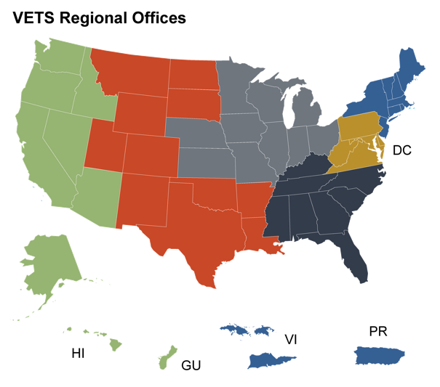
The VETS National Office is administered through six regional offices in Atlanta, Boston, Chicago, Dallas, Philadelphia, and San Francisco.
Refer to Website:
For more information about regional offices, visit:
https://www.dol.gov/agencies/‌vets/about/regionaloffices

The Mission of the U.S. Department of Labor (DOL) is to “foster, promote, and develop the welfare of the wage earners, job seekers, and retirees of the United States.”
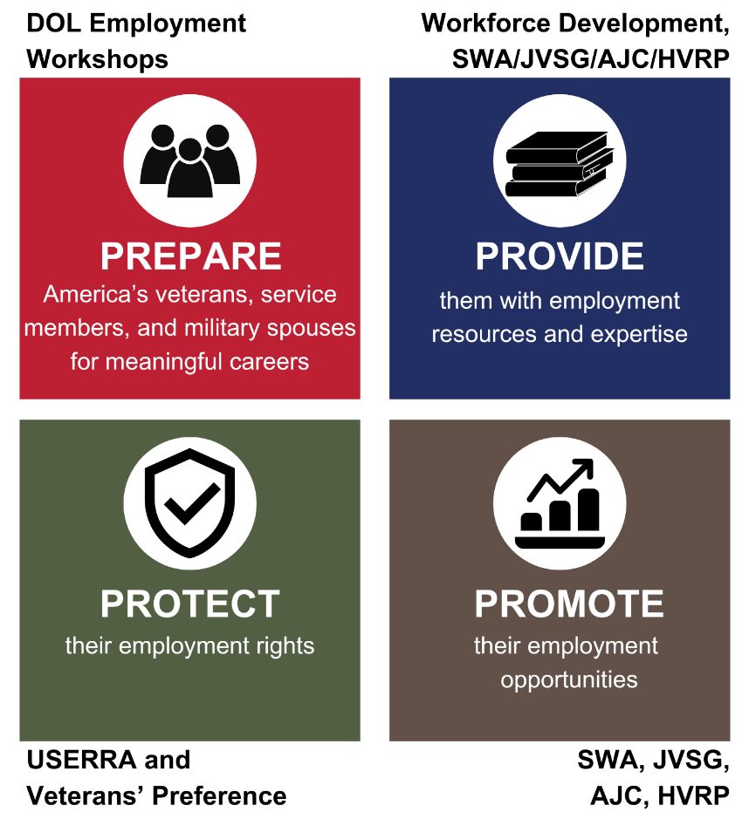
The Mission of the Veterans’ Employment Training Service (VETS) is to “prepare America's veterans, service members, and military spouses for meaningful careers, provide them with employment resources and expertise, protect their employment rights, and promote their employment opportunities.”

Each Regional Office  is led by a Regional Administrator for Veterans’ Employment and Training (RAVET). | Each State Office  is led by a Director for Veterans’ Employment and Training (DVET) and, depending on size, may have an Assistant Director(s) for Veterans’ Employment and Training (ADVET), and/or a Veterans Program Assistant (VPA).
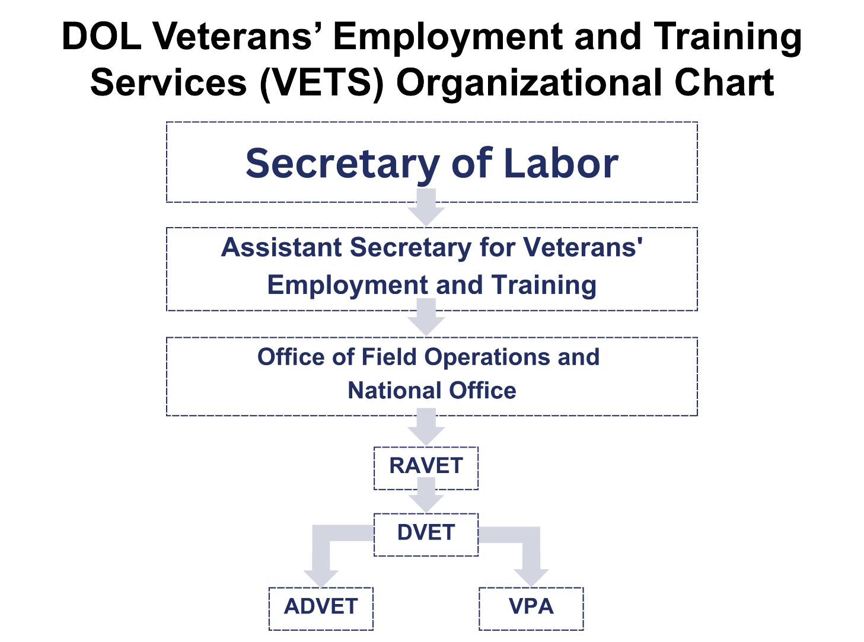

WHAT ARE JOBS FOR VETERANS STATE GRANTS?

The Jobs for Veterans State Grants (JVSG) program provides federal funding, through a formula grant, to all 50 states, the District of Columbia, and certain U.S. Territories to hire dedicated staff to provide individualized career- and training-related services to eligible veterans and eligible persons with employment barriers, as well as other authorized populations, and help employers fill their workforce needs with job-seeking veterans.
The JVSG funding supports the Disabled Veterans’ Outreach Program (DVOP) specialist position, Local Veterans’ Employment Representative (LVER) staff, and Consolidate DVOP/LVER (CODL) staff.

LVERs’ principal duties are to conduct targeted outreach to employers in the area to assist veterans in gaining employment, and to facilitate employment, training, and placement services furnished to veterans in a state under the applicable state employment service delivery systems.
CODL staff perform the duties of both a DVOP specialist and a LVER.
DVOP specialists provide individualized career services and facilitate placements to meet the employment needs of eligible veterans and eligible persons experiencing barriers to employment. DVOP specialists must prioritize service to special disabled veterans, other disabled veterans, and other categories of eligible veterans in accordance with priorities determined by the Secretary of Labor. Annual appropriations acts may provide that DVOP specialists may serve certain additional populations.

WHAT IS IT LIKE TO WORK IN AN AMERICAN JOB CENTER?
AJCs are sponsored and coordinated through the DOL. American Job Centers are designed to provide a full range of assistance to job seekers under one roof including training referrals, career counseling, job listings, and similar employment-related services.
Mission of AJC  Assist job seekers, students, workers, and employers to develop their professional capacity and make sound economic decisions.  The mission aims to:  - Provide job seekers with the skills and credentials necessary to secure and advance in employment with wages that sustain themselves and their families  - Provide access and opportunities to job seekers, including individuals with barriers to employment, as defined in section 3(24) of the Workforce Innovation and Opportunity Act (WIOA), such individuals with disabilities, individuals who are English language learners, and individuals who have low levels of literacy, to prepare for, obtain, retain, and advance in high-quality jobs and high-demand careers  - Enable businesses and employers to easily identify and hire skilled workers and access assistance from human resources, including education and training for their current workforce, which may include assistance with pre-screening applicants, | writing job descriptions, offering rooms for interviewing, and consultation services on topics like succession planning and career ladder development, and other forms of assistance  - Participate in rigorous evaluation that supports continuous improvement of AJCs by identifying which strategies work best for different populations  Vision of AJC  To be the nation’s most trustworthy provider of comprehensive, integrated, relevant, and personalized workforce information through the use of an electronic delivery system; to provide tools and resources that serve individuals in enhancing their employment opportunities.  The vision for the AJC network reflects the longstanding and ongoing work of dedicated workforce professionals to align a wide range of publicly or privately funded education, employment, and training programs with one another, while also providing high-quality customer service to all job seekers, workers, and businesses.

AJCs provide many tools and resources to job seekers and employers, including but not limited to:

Career management

Assistance acquiring a desired career

Employment information and inspiration for potential careers

Job Seekers | Employers
Benefits provided to job seekers include:  - Expanded workforce services for individuals at all levels of skill and experience  - Access to multiple employment and training resources  - Integrated and expert intake process for all customers entering the AJC  - Integrated and aligned business services strategy among AJC partners  - Expert advice from multiple sources  - Relevance to labor market conditions  - Expanded community and industry outreach  - Strengthened partnerships  - Efficient use of accessible information technology | Benefits provided to employers include:  Help finding skilled employees that fit their needs.  - Customized screening and referral of qualified participants in career and training services to employers  Assistance writing/reviewing job descriptions and employee handbooks  Coordinated business services activities across AJC programs  Partners who have a clear understanding of industry skill needs









Staff Roles in An American Job Center
The staff found in AJCs may include the following:
- Intake staff member (typically an Employment Services Interviewer)
- Staff member who conducts the initial assessment (funded under the Wagner-Peyser Act)
- Workforce Innovation and Opportunity Act (WIOA) staff
- Business Service Team (BST) member
- JVSG-funded staff members:
  - Disabled Veterans’ Outreach Program (DVOP) specialist
  - Local Veterans’ Employment Representative (LVER)
  - Consolidated DVOP/LVER (CODL) staff position
The exact job title of these staff members may vary depending on the state they work in.

Non-JVSG Staff Funded Roles

Intake Staff Member
The intake staff member is usually the first person that a veteran at an AJC would interact with. Their primary role is to determine the reason for an individual’s visit to the AJC. They may also provide the initial determination of whether an individual meets the definition of an eligible veteran or other authorized population as prescribed by law. They also sometimes share the role of a staff member conducting the initial assessment. This role may not exist in some states if the intake process is an automated electronic process completed in the AJC’s resource room area. Once the intake staff member has determined the appropriate staff person to assist the job seeker, they make a referral.


Staff Conducting Initial Assessment
The staff member who conducts the initial assessment is a non-JVSG role that is designated specifically for job seekers and is sometimes combined with the intake process. They conduct an assessment to determine priority of service and whether a participant is eligible. Eligible populations are referred to a DVOP specialist if one is available. If the individual does not meet eligibility criteria, other AJC staff can assist them with receiving appropriate services that are available at the AJC such as resume writing, computer skills, and interviewing techniques. If they need more specialized training, they will work with another service provider within an AJC. The staff also have a broad knowledge of other services available to clients from other governmental agencies and community-based organizations.


Workforce Innovation and Opportunity Act (WIOA) Staff
As described under Title I of the WIOA, the WIOA staff focuses on serving individuals identified as facing adversity with obtaining employment. Should a veteran need their services, they would assist individuals with services that prepare them with the skills needed on the job, such as providing skills-gap training for individuals needing certification or licensure. The type of training that WIOA staff assists veterans with varies depending on the state in which they work. Local colleges or businesses may reach out with potential training ideas and if they are approved, WIOA staff will match veterans to any approved training that best fits their needs/wants.


Business Service Team (BST) Member
The Business Service Team (BST) member is a part of the AJC staff and is essentially responsible for coordinating with the community and employers to promote and secure employment and training opportunities for all job seekers.

JVSG Staff Funded Roles

DVOP Specialist
The DVOP specialist works directly with eligible veterans and eligible persons who have employment barriers and other authorized populations, as identified in VETS policies; their duties are outlined in 38 U.S.C. 4103A. The services provided by a DVOP specialist are referred to as individualized career services. These services include, but are not limited to:
- Comprehensive and specialized assessments of skill levels and service needs
- Development of an individual employment plan (IEP) to identify the employment goals, appropriate achievement objectives and appropriate combination of services for the participant to achieve the employment goals
- Career planning
- Short-term prevocational services that may include development of learning skills, communication skills, interviewing skills, punctuality, personal maintenance skills, and professional conduct to prepare individuals for unsubsidized employment or training services
A full list of services can be found in 20 CFR § 678.430.
DVOP specialists focus on providing individualized career services through the case management framework, as taught by the National Veterans’ Training Institute (NVTI). This framework includes three elements: comprehensive assessment, employment plan, and consistent contact. Additionally, DVOP specialists build relationships and conduct outreach and recruitment activities with other service providers in the local area to enroll eligible and priority category persons in an AJC.
A DVOP specialist needs to establish a strong rapport and relationship with the eligible populations they serve, to provide them with the best services possible to help them reach their employment goals.

LVER Staff
LVERs conduct outreach to the employer community and facilitate employment, training, and placement services under the state’s employment service delivery system. States must assign LVERs duties that inform employers, employer associations, and business groups of the advantages of hiring veterans. LVER duties are outlined in 38 U.S.C. 4104(b).
LVERs should advocate for all veterans and the additional populations identified by the Secretary with business, industry, and other community-based organizations by participating in appropriate activities. These activities include, but are not limited to:
- Planning, conducting, and participating in job and career fairs
- Conducting employer outreach, including facility tours or interviews with current employees to familiarize themselves with job responsibilities or qualifications
- Assisting with job development for veterans, eligible persons, and other DVOP-eligible populations enrolled in workforce development programs
- Facilitating job search workshops/groups, on behalf of/in conjunction with employers, provided that DVOP and/or other AJC staff are available to deliver any needed direct services
- Working with established unions, apprenticeship programs, and businesses or business organizations to promote and secure employment and training for veterans
- Informing federal contractors of the process to recruit qualified veterans
- Promoting initiatives and programs such as the DoD SkillBridge program and the HIRE Vets Medallion Program and assisting local area employers in applying for the award when appropriate
LVERs play an important role in developing the veteran service delivery strategies in the state workforce system, educating all AJC staff with current veterans’ employment initiatives and programs, and providing regular updates on veteran services and programs.
In the course of their work, LVERs can leverage VETS’ Regional Veterans’ Employment Coordinators (RVEC), who engage with local, regional, and national employers and connect them with federal, state, and local resources to facilitate veterans’ employment.
Refer to Website:
To find contact information for your RVEC, visit: https://www.dol.gov/agencies/vets/employers/hire


CODL Staff
CODL staff perform both the duties of a DVOP specialist and an LVER. When reading any guidance that pertains to DVOP or LVER duties, keep in mind that the guidance is also applicable to CODL staff, who may perform those duties in any mix (50/50, 80/20, etc.).


WHAT LEGAL AND REGULATORY GUIDANCE AFFECTS MY WORK?
The United States Code (U.S.C.) that is relevant to DOL VETS’ authority under the JVSG program is Title 38, Chapters 41 and 42.
- Chapter 41, Section 4102A discusses allowance for a JVSG staff person to perform duties of a DVOP specialist, LVER staff, and CODL staff.
- Chapter 41, Section 4103A
discusses the Disabled Veterans’ Outreach Program
- Chapter 41, Section 4104 discusses Local Veterans’ Employment Representatives
- Chapter 42, Sections 4211—4215
provide detailed descriptions for many of the terms relevant to DOL VETS under the JVSG program.
Refer to Website:
For more information about Title 38 Chapters 41 and 42, visit the NVTI Glossary: https://www.nvti.org/resources/nvti-glossary



Law & Policy for DVOP Specialists

Legislation and/or Regulations | Description
U.S.C. Title 38, Chapter 41, Section 4103A | U.S.C. Title 38, Chapter 41, Section 4103A requires that Disabled Veterans’ Outreach Program specialists provide individualized career services (intensive services) and facilitate job placement to eligible veterans.
Public Law 113-128, the WIOA, Section 134(c)(2) | Public Law 113-128, WIOA, Section 134(c)(2) outlines the individualized career services (also previously known as intensive services) that are to be provided by the Disabled Veterans’ Outreach Program specialist to eligible participants.
Annual Appropriations Act | The Annual Appropriations Act includes language authorizing DVOP specialists to serve eligible transitioning service members and members of the armed forces who are wounded, ill, or injured receiving treatment at a warrior transition unit or military treatment facility, as well as the spouses or caregivers of such wounded, ill, or injured members.
VPL 01-20 | VPL 01-20 clarifies the process to consolidate the DVOP specialist and LVER staff roles into full-time consolidated DVOP/LVER positions.
VPL 05-24 | VPL 05-24 identifies and consolidates the roles, responsibilities, and duties that the Jobs for Veterans State Grant (JVSG) staff are expected to perform and discusses the relationship between JVSG and other programs within the workforce development system.
Refer to Website:
For more information about legislation and regulations specific to DVOP specialists and to access online training for serving eligible populations visit: https://www.nvti.org/resources/


Law & Policy for LVERs

Legislation and/or Regulations | Description
U.S.C. Title 38, Chapter 41, Section 4104 | U.S.C. Title 38, Chapter 41, Section 4104 lists the principal duties of Local Veterans’ Employment Representatives.
VPL 01-20 | VPL 01-20 clarifies the process to consolidate the DVOP specialist and LVER staff roles into full-time consolidated DVOP/LVER positions.
VPL 05-24 | VPL 05-24 identifies and consolidates the roles, responsibilities, and duties that the Jobs for Veterans State Grant (JVSG) staff are expected to perform and discusses the relationship between JVSG and other programs within the workforce development system.
Refer to Website:
For more information about legislation and regulations specific to Local Veterans’ Employment Representatives visit:
https://www.nvti.org/resources/

Refer to Website:
For more information about Veterans’ Program Letters (VPLs) visit: https://www.dol.gov/agencies/vets/resources/VPLS/VPLDirectory where you can also subscribe to receive updates about these resources. You may also access these resources by visiting: https://www.nvti.org/resources/

RELEVANT TRAINING AND EMPLOYMENT NOTICES (TENs)
A Training and Employment Notice (TEN) is a notice published by DOL that provides information to states and training providers about their requirements and responsibilities. While there are not any Training and Employment Notices (TENs) that correspond to any specific VPLs, there are a few TENs that are relevant to the JVSG program requirements and DVOP specialist and LVER staff roles and responsibilities. These TENs are listed on the pages that follow.
Refer to Website:
For more information about TENs visit: https://www.dol.gov/agencies/eta/dinap/training-employee-notices subscribe to receive updates about these resources. You may also access these resources by visiting: https://www.nvti.org/resources/


PRIORITY OF SERVICE FOR COVERED PERSONS
The Employment and Training Administration (ETA) and Veterans’ Employment and Training Service (VETS) provide priority of service implementation policy guidance in Training and Employment Guidance Letter (TEGL) 10-09 and VPL 07-09. The VPL and TEGL explain that veterans and eligible spouses are eligible for priority of service.
VPL 07-09, TEGL 10-09, and Title 20 of the CFR, Section 1010 define veterans and eligible spouses and explain the provision of priority of service for covered persons (i.e., veterans and eligible spouses) over non-covered persons for the receipt of employment, training, and placement services under a qualified job training program, funded in whole or in part by the Department of Labor.
TEGL 10-09 states:
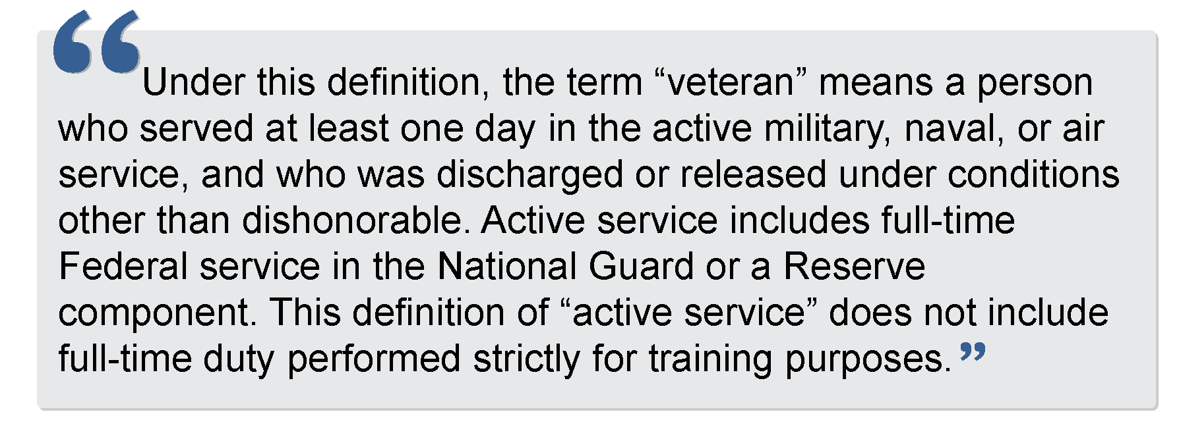

U.S.C. Title 38, Chapter 42, Section 4215(a) states an eligible spouse means one of the following:
- Any veteran who died of a service-connected disability
- Any member of the Armed Forces serving on active duty who, at the time of application for priority of service, is listed in one or more of the following categories and has been so listed for a total of more than 90 days:
  - Missing in action,
  - Captured in line of duty by a hostile force, or
  - Forcibly detained or interned in the line of duty by a foreign government or power.
- Any veteran who has a total disability resulting from a service-connected disability, as evaluated by the Department of Veterans Affairs
- Any veteran who died while a disability, so evaluated, was in existence.

DVOP Eligible Populations:

ELIGIBLE PERSONS
DVOP specialists provide individualized career services and facilitate placements to meet the employment needs of eligible veterans and eligible persons. DVOP specialists must prioritize service to special disabled veterans, other disabled veterans, and other categories of eligible veterans in accordance with priorities determined by the Secretary of Labor. Annual appropriations acts may provide that DVOP specialists may serve certain additional populations.
VPL 05-24, defines the criteria barriers to employment and provide expansion and clarification of employment barriers. States may use an Eligibility Screening Form to determine eligibility for DVOP specialist services.
Refer to Website:
You may learn more about the Eligibility Screening Form by watching NVTI’s microlearning on this topic at: https://www.nvti.org/on-demand-learning/microlearning/ under the topic heading Serving Veterans.

Serving Veterans Entitled to Benefits Under the Chapter 31 Program
Veteran Readiness and Employment (VR&E) participants are often referred to AJCs for assistance as they approach the end of their training. Those participants are often served by DVOPs. The VA's counselors will need additional information from the DVOP or other AJC staff who are serving them. VA and VETS are working to update guidance on this topic and NVTI will offer training when that happens.
Within the framework identified in the Technical Assistance Guide (TAG), DVOP specialists are tasked with providing labor market information for the VA/VR&E service to use in developing the veteran’s Individualized Written Rehabilitation Plan (IWRP) and Employment Services during the employment phase of the veteran’s rehabilitation.

Workforce Innovation and Opportunity Act (WIOA)
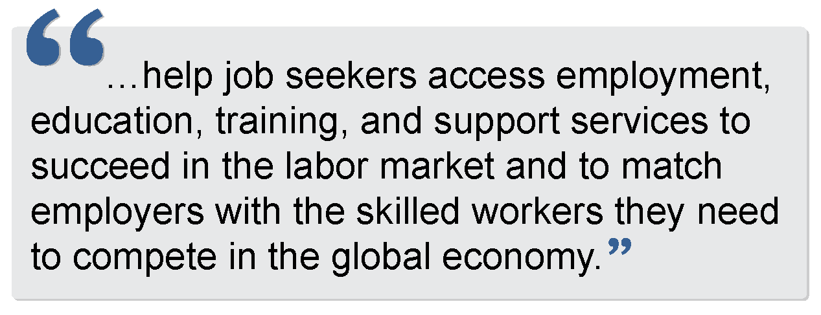
The WIOA was signed into law in July 2014. Its purpose is to:

WIOA focuses on serving populations with barriers to employment. These priority populations include:
- Recipients of public assistance
- Other low-income individuals
- Individuals who are basic skills deficient. Basic skills deficient is defined as someone:
  - Who is a youth, with English reading, writing, or computing skills at or below the 8th grade level on a generally accepted standardized test.
  - Who is a youth or adult, that is unable to compute or solve problems, or read, write, or speak English, at a level necessary to function on the job, in the individual’s family, or in society.


Priority of service in relation to WIOA is provided using the following order:

to non-covered persons (that is, individuals who are not veterans or eligible spouses) who are included in the groups given priority for WIOA adult formula funds.
to veterans and eligible spouses who are also included in the groups given statutory priority for WIOA adult formula funds. This means that veterans and eligible spouses who are also recipients of public assistance, other low-income individuals, or individuals who are basic skills deficient would receive first priority for services provided with WIOA adult formula funds.
.

to veterans and eligible spouses who are not included in WIOA’s priority groups.
to priority populations established by the governor and/or local Workforce Development Board and then non-covered persons outside the groups given priority under WIOA.

Refer to Website:
For more information about WIOA visit: https://www.dol.gov/agencies/eta/wioa or https://www.nvti.org/resources

The Wagner-Peyser Act
In 1933, the Wagner-Peyser Act was established, creating the Employment Service which brings together job seekers and employers seeking workers.
In 1998, the act was amended to make the Employment Service part of the One-Stop delivery system under the Workforce Investment Act.
In 2014, the act was amended again under WIOA. Under WIOA, the act builds upon the previous workforce reforms, requires the placement of Employment Service offices into the AJCs nationwide, and aligns performance accountability indicators with other federal workforce programs.
Job seekers who are veterans or other eligible persons are to receive priority for job referrals, training programs, and other services.
Refer to Website:
For more information about the Wagner-Peyser Act visit: https://www.dol.gov/agencies/eta/performance/results/wagner-peyser

The HIRE Vets Act / HIRE Vets Medallion Program

The Honoring Investments in Recruiting and Employing American Military Veterans Act of 2017 (HIRE Vets Act or the Act), requires the Secretary of Labor to establish a program that recognizes employer efforts to recruit, employ, and retain veterans. The HIRE Vets Medallion Program (HVMP) codifies the requirements of the Act, including criteria for employer awards. The HIRE Vets Medallion Award is the only federal-level veterans’ employment award that recognizes a company or organization’s commitment to veteran hiring, retention, and professional development.

Tip:
Part of a LVER’s role is to promote the HIRE Vets Medallion Program and assist local area employers in applying for the award when appropriate.
Refer to Website:
For more information about the HIRE Vets Act visit: https://www.hirevets.gov/about

ADDITIONAL GUIDANCE TO GET STARTED

The National Veterans’
Training Institute

The National Veterans’ Training Institute (NVTI) provides specialized training and professional skills enhancement for veterans’ service providers staff, including JVSG-funded staff. Focusing primarily on training individuals who help veterans secure long-term employment, NVTI is committed to ensuring that those who are tasked with this critical responsibility have the knowledge and tools necessary to perform their jobs effectively. NVTI is funded by DOL VETS.
NVTI does not directly work with or train veterans. NVTI is a contract program from DOL VETS. NVTI is mandated by law (U.S.C. Title 38, Section 4109) to provide specific training to certain groups, namely veterans’ employment and training professionals including employment service personnel, VETS and state staff, Department of Defense personnel, and others.
Refer to Website:
For more information about NVTI visit: https://www.nvti.org/

Required Courses:
9635: A Day in the Life of JVSG Staff in an American Job Center
Duration: 1.5 to 3 hours for completion
This course presents a broad overview of how an AJC operates and the roles and responsibilities of each staff member.
9636: Legal Guidance Affecting Veterans’ Employment Services
Duration: Approximately 20 hours over 4 weeks for completion
This course presents important provisions of veteran-related legislation and regulations and the legal relationships between AJC staff
9637: Removing the Employability Gap for Veterans with Significant Barriers to Employment
Duration: Approximately 10 hours over 2 weeks for completion
This course presents strategies for effectively developing working relationships with veterans and techniques to interact with veterans and employers.


Role-Specific Core Competency Courses:

DVOP Only: 9608: Disabled Veterans’ Outreach Program (DVOP) Specialist Core Competency Development

This course provides DVOP specialists with the training, skills, and tools needed to assist veterans with finding and keeping meaningful employment. From building relationships with veterans to developing concrete plans that will enable veterans to transition from unemployment to following a promising career path, participants will engage in exercises, discussions, and activities that will prepare them to tackle the unique obstacles they face on the job.

LVER Staff Only: 9609: Local Veterans’ Employment Representative (LVER) Core Competency Development

Local Veterans’ Employment Representatives (LVERs) advocate for job-seeking veterans by serving as liaisons with employers and training providers. This course empowers LVERs to conduct a variety of outreach activities, thus facilitating employment opportunities for job-seeking veterans through their AJCs (AJCs). Participants are provided with the strategies and tools they need to help veterans gain and maintain meaningful employment.
Refer to Website:
For additional information and training opportunities, visit: https://www.nvti.org/Training/Class-Descriptions/

Please note: VPL 01-20 provides for Consolidated DVOP/LVER staff positions. All required training for both DVOP specialist and LVER staff positions must be successfully completed within 8 months of appointment.


Please speak with your supervisor to receive guidance to register for NVTI training.
Refer to Website:
For additional information and training opportunities, visit: https://www.nvti.org/logistics/registering-for-nvti-classes/

Employment Plan
The Employment Plan may also be known as an Individual Employment Plan, plan of action, Individual Development Plan, etc. The participant and DVOP specialist jointly develop the employment plan. It captures the individual’s career goals, steps needed to achieve the goals, and actions taken by both the individual and the DVOP specialist. The employment plan must address all barriers identified in the comprehensive assessment (e.g., lack of transportation), not just the barriers that made the participant eligible for DVOP services.
Employment Plans:
- Provide a plan for the participant that will also help guide the DVOP specialist. A plan provides steppingstones to goal achievement and provides accountability for those involved.
- Help set expectations. Both the DVOP specialist and participant will be on the same page.
- Build self-esteem. An employment plan helps participants see that their goals are attainable.
- Provide a guide for effectively assisting the participant. Align your goals and plans with those of the veteran with whom you are working.
- Increase the number of placements and success stories. When goals are written down, multiple people can have access to them, allowing for the increase of assistance provided for a participant. Also, it’s been noted that goals that are written down are more likely to be met.
- Help facilitate meaningful follow-up. This provides the DVOP specialist with a reason to follow up with participants to monitor their progress toward goal achievement.

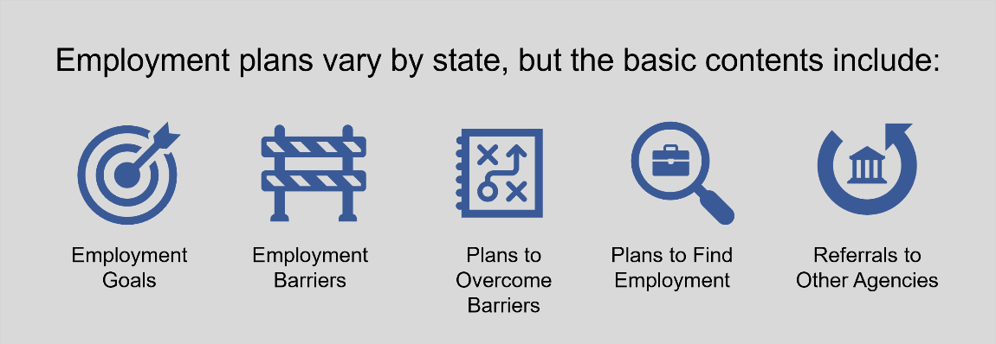
EMPLOYMENT PLAN CONTENTS
Refer to Website:
For more information about employment plans watch NVTI’s microlearning by visiting: https://www.nvti.org/on-demand-learning/microlearning/serving-veterans/

Comprehensive Assessment
A comprehensive assessment is an in-depth evaluation that documents the individual’s employment barriers and pertinent history, such as education, skills, and job history. It is used to identify barriers to employment by obtaining as much information as possible related to attaining and maintaining employment. A common method for administering and conducting these assessments is to use informal assessments such as a structured interview. There is no one instrument or technique that can provide all the answers, which is why attempts to get as many pieces of the puzzle as possible are important.
Conducting a comprehensive assessment requires a lot of active listening and focus. This comprehensive evaluation serves to understand the participant holistically by finding out where the participant is, what they have done, what they want to do, and what barriers they need to overcome. It is only through accurate and ongoing assessment that an employment plan can be created, implemented, monitored, modified, and completed.
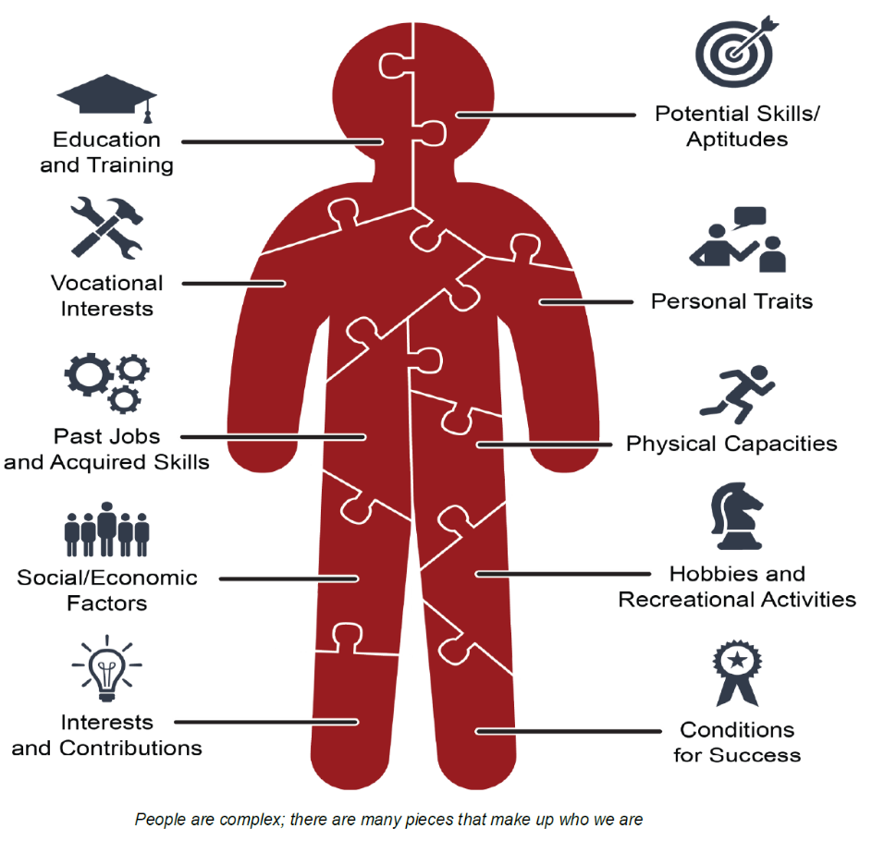
Preparing Interview Questions:
- Start easy. Initially keep the questions less personal; save the more controversial or personal questions for later.
- Keep it simple and specific. Ask one question at a time and keep the wording simple and specific. Define anything that may be unfamiliar.
- Remain neutral. Keep the wording of questions neutral and non-judgmental. Avoid leading questions. You do not want to project your values and judgements onto others. Be aware of asking why questions—they tend to put people on the defensive and may affect your rapport with an individual.
- Focus on the objective. Remember what the objective of the interview is; it could be different for each individual. When working with someone who is experiencing homelessness, you want to determine how the current situation occurred and how motivated they are to change their lifestyle. If someone is missing a limb, the more prominent issue is where they are mentally in accepting the situation as well as how the injury will affect work in occupations of interest.
- Embrace silence. Try to avoid speaking in moments of silence; at times this can be an effective communication tool and encourages an individual to talk more and reveal more information.
- Be open to questions. Give an individual the opportunity to ask questions. Ask them if they have any questions periodically or if something appears to be unclear.
- Summarize. Wrap up the interview by summarizing what has been discussed and the next steps. This information should be in the plan, and the participant should always leave with a copy of the plan for follow-up. It provides the participant with a step-by-step guide for their goals that they can cross off and monitor.

Consistent Contact
DVOP specialists must maintain regular, consistent contact with the participant, including meetings and updates, both pre- and post-employment. Contact with a participant should be meaningful to continually assist the participant in overcoming employment barriers to find and maintain employment. Consistent contact is based on the participant’s individual needs and situation, as per the written plan and case notes. This also includes any documented attempts at contact, but it does not include mass or group communications such as an email newsletter.
Refer to Website:
To learn more about Case Management, check out the 9620 course at:
https://www.nvti.org/Training/Class-Descriptions/

Additional NVTI Resources

JVSG New Hire
Refer to Website:
For an aggregated list of helpful resources for new hires including training plans, journey maps, and information on certificate programs, visit: https://www.nvti.org/on-demand-learning/jvsg-new-hire-resources/

Microlearning
Refer to Website:
For brief, informative microlearning on a variety of helpful topics, visit: https://www.nvti.org/On-Demand-Learning/Microlearning/

NVTI Learning Ecosystem
Refer to Website:
To view an outline of NVTI’s available offerings, visit: https://www.nvti.org/app/uploads/2023/11/NVTI-Learning-Ecosystem.pdf

NVTI-JVSG Journey Map
Refer to Website:
To view the NVTI-JVSG Journey Map, visit: https://www.nvti.org/app/uploads/2023/11/JVSG-Journey-Map-08_08_23.pdf

JVSG Training Plans
Refer to Website:
To learn more about the JVSG Training Plans, visit: https://www.nvti.org/training/training-plans/

Certificate Program
Refer to Website:
To learn more about the NVTI Certificate Program, visit: https://www.nvti.org/training/certificate-program/

Subscribe to the NVTI Newsletter
Refer to Website:
To subscribe to the NVTI Newsletter, visit: https://www.nvti.org/Subscribe-to-Mailing-List/

WHAT RESOURCES MIGHT I FIND USEFUL TO REFERENCE?
Website | Description
DOL VETS  https://www.dol.gov/agencies/vets | United States Department of Labor – Veterans’ Employment and Training Services (DOL VETS). Resources for all veterans, including information on finding a job, starting a business, hiring veterans, VA benefits and information, and military spouses.
O*Net Online  https://www.onetonline.org/ | A tool for career exploration and job analysis.
Career One Stop  https://www.careeronestop.org/ | The source for career exploration, training, & jobs sponsored by the U.S. DOL. You will also find additional resources for veterans and their spouses on the Career One Stop site.
HIRE Vets Medallion Program  https://www.hirevets.gov/  https:/www.HIREVets.gov/Awardees | Recognizes employers for their investments in recruiting, employing, and retaining our nation’s veterans.  Live map and table of current and past award recipients
National Association of State Workforce Agencies (NASWA)  https://www.naswa.org/ | The national organization representing all 50 state workforce agencies, D.C. and U.S. territories. NASWA provides policy expertise, shares promising state practices and promotes state innovation and leadership in workforce development.
Veterans Career Fairs—American Legion  https://www.legion.org/careers/jobfairs | The American Legion’s Career Fairs site.
Veterans Career Fairs—DAV  https://www.dav.org/get-help-now/employment-entrepreneurship/job-fairs/ | DAV is a nonprofit charity that focuses on connecting veterans with meaningful employment and resources.
Employer Support of the Guard and Reserve (ESGR)  https://www.esgr.mil/ | ESGR, a Department of Defense program, was established in 1972 to promote cooperation and understanding between Reserve component service members and their civilian employers and to assist in the resolution of conflicts arising from an employee's military commitment.
Marine for Life Network (M4L)  https://www.usmc-mccs.org/marine-family-support/transition-readiness/marine-for-life-network# | Connects transitioning Marines and their family members to education resources, employment opportunities, and other veterans’ services that aid in their career and life goals outside of military service.
Military Officers Association of America (MOAA)  https://www.moaa.org/ | The nation's largest and most influential association of military officers. They represent the interests of military officers and their families at every stage of their careers
United States Army Soldier for Life (SFL)  https://soldierforlife.army.mil/ | The Soldier for Life (SFL) program improves soldier, family, and Army readiness by developing a broad network of resources to support every soldier, veteran, and family member through all phases of their service.
Student Veterans of America  https://studentveterans.org/ | Student Veterans of America’s mission is to provide military veterans with the resources, support, and advocacy needed to succeed in higher education and following graduation.
United States Chamber of Commerce Foundation – Hiring Our Heroes  https://www.uschamberfoundation.org/solutions/workforce-development-and-training/hiring-our-heroes | Nationwide initiative to help veterans, transitioning service members, and military spouses find meaningful employment opportunities.
National Veterans’ Training Institute (NVTI)  https://www.nvti.org/ | NVTI was established to develop and enhance the professional skills of veterans' employment and training service providers throughout the United States. NVTI provides classes and resources such as webinars, microlearning, podcasts, and a Community of Practice to support VETS service providers
WorkforceGPS  https://www.workforcegps.org/ | WorkforceGPS is an online technical assistance site created to help build the capacity of America's public workforce investment system.

ACRONYMS & GLOSSARY
Refer to Website:
For a comprehensive list of acronyms and terms relevant to veteran service providers, visit: https://www.nvti.org/resources/nvti-acronyms/ and https://www.nvti.org/Resources/NVTI-Glossary/

CONCLUSION
Thank you for taking the time to review this primer document. Congratulations once again on your recent appointment! By understanding the legal requirements, mission, vision, policies, and your responsibilities outlined here, you are well-equipped to support job-seeking veterans effectively. We wish you success in your new role and look forward to your contributions in serving our veterans. Remember, as you start this new role, NVTI will be there to support you as you progress throughout your career.

